**Royal Conservatoire of Scotland contemporary guitar projects**The composer and the performer: an intertwined relationship

Marco Ramelli



This thesis is submitted in partial fulfilment for the degree of DPerf  
at the   
University of St Andrews

Date of Submission

Preface

This thesis aims to give a reflective synthesis of my practical research on the relationship between performer and composer, a collaboration that has been the subject matter of my study and has involved me as a researcher, performer and composer.

My research stands out from the previous studies because it attempts to look at the collaboration between the guitarist and the composer from different perspectives. Indeed, it provides new insight on the topic by experiencing different types of collaborations from different roles; my multi-angled study was possible thanks to a variety of artistic projects in which I worked either as a researcher, a guitarist or a composer. This written work outlines my contribution to all these projects and discusses the artistic insight achieved through my program of study.

The thesis is divided into three chapters preceded by a section summarising the characteristics of the collaboration between guitarists and composers in the nineteenth and twentieth centuries. In the first chapter, I present the different artistic projects carried out during my doctorate. Chapter 2 introduces the different roles of the guitarists in their relationship with the composers, while Chapter 3 discusses the process of revision; in both chapters, I will investigate the subjects by using examples from the artistic projects. In the conclusions of the last two chapters, I will draw up two ideas that have been inspired by the artistic projects.

TABLE OF CONTENTS

***Preface 6***

***The context: The relationship between composer and guitarist 11***

***Cap 1 Artistic projects 15***

**Cap 1.1 Thomas Wilson guitar music (Artistic project 1) 15**

1.1.1 Working on the performance edition 16

1.1.2 Discovering the genesis of the work: *Antoni* *Gaudi (pieces for guitar)* 17

**Cap 1.2 Dedicatee's point of view (Artistic project 2) 19**

**Cap 1.3 The composer's point of view (Artistic project 3) 22**

**Cap 1.4 A posthumous collaboration (Artistic project 4) 24**

Cap 1.4.1 Fantasia 26

Cap 1.4.2 For Whom the Bell Tools 30

**Cap 1.5 Development project: the collaboration between guitarist and luthier 36**

***Cap 2 The Role of dedicatee 38***

**Cap 2.1 Before the start of the composition 39**

2.1.1 The dedicatee as a medium between the composer and the guitar 39

2.2.2 Give the composer stimuli for the creation of the piece 43

**Cap 2.3 During the compositional process 45**

**Cap 2.4 When the composition is finished but requires revision 47**

**Cap 2.5 When a composition has reached the final stage 48**

***Cap 3. Revision as Negotiation 51***

**Cap 3.1 The concept of negotiation 52**

3.1.1 Interpretation of the source text  53

3.1.2 Identification of problems in the realization on the instrument 56

3.1.3 Negotiation 57

3.1.4 Losses and compensations 59

**Cap 3.2 A case study: In Absentia Essentia 60**

3.2.1 Interpretation: Discovering the music 62

3.2.2 Discovering the obstacle 66

3.2.3 Negotiation 67

***Conclusion 70***

***References 71***

The context: The relationship between composer and guitarist

Before focusing on the collaboration between composer and guitarist, it is worth considering why this relationship was neglected by non-guitarist composers during the nineteenth century.

At that time, even though the guitar was already popular, composers were not inclined to write for this instrument. One reason may be that it was considered almost impossible for a non-expert guitarist to write for it, as Hector Berlioz clearly states in his Treatise on Instrumentation: "One cannot compose for the guitar well unless one is a guitarist" (Berlioz, 1844).

Why is the guitar such a difficult instrument to write for? This question is of key importance to understand what followed in the next century. The difficulties are linked to some aspects of the structure and nature of the instrument:

* Guitar tuning: The guitar is tuned in fourths, with the exception of the third major interval between the second and third open strings. This particular tuning makes the composition process more challenging compared to the more comprehensible keyboards of the symphonic strings.
* Polyphonic/monodic writing: The guitar is an instrument that can be used in either melodic or polyphonic compositions, however, it presents considerable limitations in both cases. Indeed, in comparison with the more 'melodic' strings and wind instruments, composers face more difficulties when delineating melodic passages because of the restrained volume and sustain of the guitar; similarly, in polyphonic passages the guitar presents a limited range compared to the keyboard, making idiomatic writing quite challenging.
* Almost every single sound is produced by using both hands simultaneously and only four fingers per hand, raising further limitations as the fingering certainly requires special attention.
* Using the expressive potential of the instrument: Already since the nineteenth century, it was widely accepted that the tone and the possibility of producing different types of sound were the most outstanding qualities of the instrument. The same musical content can be played on the guitar by using different strings, fingerings or techniques, greatly affecting the expression and tone of the musical passage. Practical knowledge of the instrument is needed in order to compose a piece that highlights those potentials.
* Difficult tonal modulation: Modulation is not easy on the guitar, especially in polyphonic writing. This was a big restriction for the composers during the romantic period, when modulation was becoming a central element of the musical language.

In the twentieth century, two closely related factors contributed to the flourishing of collaborations between composers and guitarists. First, towards the end of the previous century, the instrument underwent a rapid development thanks to a new guitar project conceived by Antonio de Torres Jurado (1817 –1892) that quickly spread. Second, the evolution of the instrument is concurrent with the presence of excellent virtuosos who developed new techniques.

However, this change is not the only reason that aroused the interest of composers in the instrument, also the new artistic sensitivity emerging between the two centuries played an important role, The poetic and mysterious sound of the guitar - as often described by poets such as Garcia Lorca - perfectly fitted the evocation of the archaic worlds that attracted the artists of the time. However, the difficulties in composing for the guitar still remained and, although composers started being inspired by the sound of the guitar, they were still reluctant to write for it. Writing for the guitar was still considered too complicated.

Initially, the guitarist-composer relationship started as a necessity to overcome the difficulties faced by the composers through complementary collaborations. In complementary collaboration - as presented by Barrett on Vera John-Steiner's seminal book *Creative Collaborations* (Barrett, 2000) - the two subjects share their knowledge and experience filling their reciprocal gaps. In this case, the guitarist assists the composer in various phases of the creative process, facilitating the use of idiomatic writing, which is suitable for the technique of the instrument. Thanks to this, the composer can avoid looking into the technical complexity of the guitar.

Andrés Segovia (1893 –1987) contributed a great deal to spreading complementary collaborations since, at the beginning of the twentieth century, he planned to expand the repertoire of the instrument by commissioning new works to some of the greatest non-guitarist composers of the time, such as Moreno-Torroba (1891-1982), Mario Castelnuovo-Tedesco (1895-1968), Joaquin Turina (1882-1949) and Manuel Maria Ponce (1882-1948). After Segovia, in the last century the number of collaborations multiplied, involving some of the most important guitarists and composers. It is not surprising that every virtuoso after Segovia collaborated with composers to try to widen their repertoire. In addition, the possibility of collaborating with renowned composers was seen by guitarists as a way to establish their position within the guitar world.

By observing all the different collaborations that guitarists and composers have established, it is likely that they are not driven only by complementary practices but also by certain benefits that go beyond complementary needs. The great variety of collaborations can be described by using the three categories discussed in the research of Hayden and Windsor (2007), which was based on a previous work by Argyris and Schon (1974):

Directive: In this category, the score is the central point of the relationship. The collaboration mostly takes place during the interpretation phase, when the composer provides indications on how to play the music.

Interactive: In the interactive collaboration, the composer and the guitarist interact, discuss and evaluate different options either during or at the end of the compositional process.

Collaborative: the composition is basically collective and decisions are often made together. Sometimes, there is no clear hierarchy of roles.

Cap 1 Artistic projects & Supplementary studies

The Doctorate in Performance is divided into four artistic projects and a Development project. While the artistic projects focus on the main theme of the research, the development project aims to expand the professional skills of the researcher. The artistic projects allowed the researcher to experience the collaboration between guitarist and composer from a different point of view, and each project involved a preliminary research phase followed by practical implementation. The outputs of the projects were diverse and included new music, performance editions, audio recordings, videos and reports on collaborations. On the other hand, the development project focused on the collaboration between composer and guitarist through the organization of two dedicated events in collaboration with Gabriele Lodi, and the creation of a new instrument in collaboration with the luthier Maurizio Foti.

In addition to the artistic projects, as part of the doctoral programme, I attended a few taught courses as supplementary studies (for a total of 120 SCQF) that helped me in developing skills necessary for my research.

**Cap 1.1 Thomas Wilson guitar music (Artistic project 1)**

In the first artistic project, I investigated the relationship between performer and composer in the context of compositions written in the past century. The research focused on the composition *Coplas del ruiseñor* written by the Scottish composer Thomas Wilson (1927-2001) in 1971 and dedicated to the Italian guitarist Angelo Gilardino.

This project mainly aimed to create a performance edition of the work and to shed more light on the genesis of the piece. My research greatly benefited from the support of Mrs Margaret Wilson, Thomas Wilson’s wife, who I had the pleasure to meet in September 2015 in Glasgow. Mrs Margaret Wilson kindly agreed to support my study by granting me access to the personal archive of Thomas Wilson. I examined in detail the following archival items:

* Eight letters from Angelo Gilardino to Thomas Wilson regarding the composition *Coplas del ruiseñor*.
* A trial recording of Angelo Gilardino playing *Coplas del ruiseñor,* which was sent to the composer in an early stage of the study of the piece to receive feedback.
* The manuscript of *Coplas del ruiseñor*,dated December 8, 1971.
* The manuscript of *Antoni* *Gaudi (pieces for guitar),* a composition commissioned by the BBC as background music for a documentary on Antoni Gaudi. Wilson used some musical material from this composition as a starting point to compose *Coplas del ruiseñor*.

I carried out an in-depth analysis of this material and made a careful comparison between the manuscript and the published version (Wilson, 1972). The archival research helped me develop a personal interpretation of *Coplas del ruiseñor*,which resulted in the preparation of a performance edition that I performed and recorded.

The following sections discuss the main aspects of the approach I used while preparing the performance edition, and how the study of the previous composition *Antoni* *Gaudi (pieces for guitar)* influenced my interpretation.

**1.1.1 Working on the performance edition**

To address the exciting task of preparing my personal version of the performance edition of *Coplas del ruiseñor*, I had to decide whether to edit the manuscript (included in Wilson’s archive) or the published version. After careful considerations, I made the decision to base my performance edition on the manuscript.

By reading Gilardino's correspondence with the composer, I inferred that most of the differences between the manuscript and the published version arose from editorial requests. In my opinion, the missing or modified elements in the published edition --such as phrase marks and some agogic indications --are fundamental elements of Thomas Wilson’s music. As Wilson himself remarked: “Music is a very complicated art and the performer needs as much help as possible, even to the extent of complementary instruction to make it clear to the performer the particular quality of sound that’s required by me. I try to help the performer to realise this” (Wilson, quoted in Wilson and Griffith, 2011).

However, while preparing the performance edition, I did not completely overlook the published version of the piece. For instance, in the only bar that required revision because it was impossible to perform it on the instrument, I opted for the solution proposed by Gilardino, which was also accepted by the composer[1].

It is worth mentioning that only a few chords in the revision of Gilardino are significantly different from the manuscript, and that these alterations were presumably made by Gilardino to enhance the technical fluidity of the passage. In my version, I kept the chords as they were written in the manuscript but I decided to include the modifications proposed by Gilardino in an appendix. It will be up to the performer to adopt these modifications in case the realisation of the passage turns out to be too complicated.

An essential part of the creation of the performance edition was the definition of fingering. Wilson’s music, in particular in the monodic sections, can be played on the instrument by using many different fingerings. In my interpretation, I tried to enlighten the lyrical aspect of his music, therefore, the melodic passages are often played on the same string trying to enhance the expressive intervals of his music.

**1.1.2 Discovering the genesis of the work: *Antoni* *Gaudi (pieces for guitar)***

Studying Wilson's collaboration with guitarists was of particular interest for my research, and *Coplas del ruiseñor* was a very important composition to address this matter as I had access to Gilardino's correspondence with the composer. Through these letters, it is possible to observe the revision process: Gilardino points out problems and suggests solutions, and the composer either accepts them or proposes new ideas or clarifies his intent.

The first version received by Gilardino was already well conceived for the instrument, only a few passages needed to be changed, while the rest of the composition was already ready to be played on the guitar. A reason that could explain the idiomaticity of the composition is the fact that Thomas Wilson, despite not being a guitarist, tried all passages on the instrument to validate their feasibility before sending the first draft to Gilardino (Wilson and Griffith, 2011, p302). Another hypothesis is that the composer collaborated with another guitarist before Angelo Gilardino. In fact, the name of the guitarist Joop Biegelaar, written in pencil on the cover page of the manuscript of *Antoni* *Gaudi (pieces for guitar)*, strengthens this assumption[2].

*Antoni* *Gaudi (pieces for guitar)* was written as incidental music for a documentary, and the composer took inspiration from this piece to compose the core musical material of *Coplas del ruiseñor* (Wilson and Griffith, 2011, p340)[3]. *Antoni* *Gaudi (pieces for guitar)* is divided into different movements, whose titles correspond to works of the Catalan architect Antoni Gaudí:

I – Antoni Gaudí

II – Palacio Guell

III – Casa Battlo – Casa Mila

III (2) – Parc Guell

IV – Chapel Guell, Sagrada Familia

The analysis of the *Antoni* *Gaudi (pieces for guitar)* manuscript was essential to develop my own interpretation of *Coplas del ruiseñor*. Although *Coplas del ruiseñor* is a piece composed of only one movement, the manuscript shows that the composer divided the composition into ten sections by using rehearsal marks. Studying *Antoni* *Gaudi (pieces for guitar)* was also the key to better interpreting the musical form of the piece: a journey through Gaudí’s masterpieces in the Catalan city. For this reason, I decided to keep the rehearsal marks in the performance edition.

Following the collaboration between Angelo Gilardino and Thomas Wilson, reading their correspondence, and understanding Gilardino’s approach to the revision was really useful for my study. Also, it was really interesting to notice how editorial reasons may influence the work of the reviser.

Tracing the origin of a composition can be a challenge because composing is not always a linear process but a more complex road that entails second thoughts, changes and influences from external factors. This complexity does not allow to look back at the history of a piece in a purely scientific (absolute) way; instead, we must try to collect as much information as possible and base our interpretation on our observations.

**Cap 1.2 Dedicatee's point of view (Artistic project 2)**

In the second artistic project, I collaborated with four composers to create new pieces for solo guitar. The aim of this project was to develop my skills in working in close contact with composers and in creating an original repertoire for the guitar.

I decided to collaborate with composers who use different musical languages and styles, and this heterogeneity was an extraordinary opportunity to challenge my ability to adapt my approach to the instrument.

The five pieces I worked on are:

* Kai Nieminen - Shades… Fantasia-Sonata
* Raffaele De Giacometti - *In Absentia Essentia*
* Raffaele De Giacometti - *Ramelliana*
* Marco De Biasi - *Vento d’inverno*
* Fabio Selvafiorita - *Prelude I and II*

As I will discuss in the next chapter, the role of the guitarist in the collaboration with a composer can vary a lot. In fact, my contributions changed on a case-by-case basis, depending on the type of collaboration and each specific piece.

I worked in a very interactive way with the composer Kai Nieminen. Despite Kai being an expert guitarist, in the composition process of *Shades…Fantasia-Sonata*,he decided not to try the piece on the instrument. This decision was made because we wanted to explore the compositional process without overthinking about the limits of the guitar and, mostly, because we wanted to experience an interactive collaboration between the composer and the guitarist. Our collaboration actually started well before the composition was written. Once Kai finished the first draft, we worked together for another year to further explore the polyphonic and timbre potential of the composition. In this process, Kai asked me to be involved not only by proposing fingerings or alternative solutions but also by suggesting new compositional ideas or changes in the score. During our continuous research, we created a sort of “*joint venture”* in which we tried to investigate together the potential of our instrument without setting well-defined roles. In this way, we transformed every movement of the piece during our collaboration.

I worked with Raffaele De Giacometti on two projects that were closely related: *In Absentia Essentia* and *Ramelliana*. Because *In Absentia Essentia* was composed without knowing the instrument, it needed a revision, as I will discuss in the chapter entitled *Revision as Negotiation.* The second composition, *Ramelliana*,is an electroacoustic composition and for this piece Raffaele elaborated different recordings of me:

* A performance of *In Absentia Essentia*.
* An improvisation on the guitar that involved the use of objects and the preparation of the instrument.
* An overtone singing improvisation.

In both pieces, the compositional process started with an improvisation, which was made by the composer in the case of *In Absentia Essentia*, and by the performer for *Ramelliana*.

During the collaborations with Fabio Selvafiorita and Marco De Biasi, the cooperation was limited to the final stage of the interpretation. The composers made helpful suggestions to develop my interpretation of the piece, and we discussed the character of the composition, the definition of the fingering and the *tempo* of the different sections.

In the case of *Vento d’inverno* by Marco De Biasi, the collaboration continued also after the first performance of the piece. Based on the experience of the first performance, I suggested the composer expanding the composition with a final coda. After Marco added it, a new version of the composition was recorded.

**Cap 1.3 The composer's point of view (Artistic project 3)**

The relationship between guitarist and composer was the leading theme also of the third artistic project, in which I switched to the role of composer. ​

I collaborated with the following guitarists who revised and performed my compositions:

* Leonardo De Marchi – *Nocturne for ten-string guitar*
* Andrea Dieci – *Fantasia*
* McNeill-Savaloni Duo – *Moon*
* Trio Poya – *Sketching the horizon on a cloudy path*
* Andrea De Vitis – *Dida’s reminiscence*
* Sean Shibe – *Im Nebel*
* Lorenzo Micheli – *Blue, homage to Van Gogh*

This part of the research was of key importance as it allowed me to experiment the collaboration from the composer's point of view in an enriching and stimulating way. In my compositional approach, writing for someone means, above all, an effort to enter in the sound and poetic world of the musician to whom I dedicate the piece. During the collaborations, while maintaining the integrity of my musical thought, I changed my ideas for each different composition and learnt from admirable musicians.

In the case of *Nocturne*, Leonardo De Marchi helped me discover and explore the ten-string guitar, and his suggestions led me to rethink and rewrite an entire central section. As I was not aware of the practical difficulties of playing on a ten-string guitar, his revision was fundamental to the process.

The collaboration with Andrea Dieci on the piece *Fantasia* involved a meticulous work when finalising the details of the composition. Indeed, the first draft was reviewed to achieve more fluency and deeper expression.

Through the pieces written in collaboration with Sasha Savaloni, *Moon* and *Sketching the horizon on a cloudy path*,I explored the use of the voice together with the guitar. I worked closely with the performers in both compositions, as most improvisatory sections reached the final notation after several sessions with the musicians.

*Dida’s reminiscence* was written for Andrea De Vitis for a specific concert dedicated to Nicolò Paganini. Our collaboration began before the compositional process when we defined the characteristics of the piece.

In the case of *Blue* and *Im Nebel*, I collaborated with the musicians mainly on the scores. After performing the compositions myself, it was of great interest to listen to the different interpretations of the two incredible musicians I worked with as they made me discover elements of the text that I had not noticed before.

The most important goal of this project was to grasp the range of difficulties that the composing process entails and that may not be obvious to the performer. Thanks to this work, I understood that the composition of a piece is a complex process involving different personal and professional traits of the composer. Working as a composer increased my empathy for this role and had a significant impact on the way I collaborate with them and on my approach to the partnership. Indeed, before proposing modifications or revisions, I am now more considerate about my judgments and devote more time to the definition of my interpretation of the work.

**Cap 1.4 A posthumous collaboration (Artistic project 4)**

In the artistic project 4, I created a new version of the composition *For Whom the Bell Tolls* by Roberto Gerhard. The composition was written in 1965 as incidental music for the television series[4] *For Whom the Bell Tolls* directed by Rex Tucker. The series consisted of four 45-minute episodes dedicated to Hemingway's masterpiece and it started on 2 October 1965. An autograph of the composition is preserved in the 'Roberto Gerhard Archive' of the Cambridge University Library but, unfortunately, the four episodes filmed in black and white have been lost.

Two composers[5] already worked on the material and created a concert piece out of Gerhard’s fragments. I decided to elaborate a new version in order to highlight some aspects of the autograph that were not explored in the two published versions. I tried to keep the strong connections between the music and the plot of Hemingway’s masterpiece. This approach was based on the hypothesis that Gerhard did not conceive the music merely as a background comment to the movie scene but rather as a way to reflect the main themes of the book: love and war. My assumption was based on my personal interpretation of music’s symbology, quotations and recurrent motifs.

The manuscript is divided into twenty-seven fragments grouped into four parts. Most likely, each part includes the musical material related to the corresponding episode of the TV series. To be able to present the composition in concert, I needed to rethink the structure of the piece to create a sense of unity. Only a few fragments can be considered complete movements, *i.e.* with a beginning and an end, whereas the majority consists of a few bars that present one or more musical ideas.

The aim of this project was to try to develop a sort of imaginary collaboration with the composer, a *posthumous partnership* in which the dialogue with the composer was possible through the *medium* of the manuscript. To create this imaginary collaboration, I needed not only to study the score but also to get a clear idea of the personality of Gerhard and his approach to music. For this reason, before working on *For Whom the Bell Tolls*, I researched extensively about Gerhard and I read several books dedicated to him (Homs, 1962; Gerhard, 2000; Mccutcheon, 2010; Sánchez de Andrés, 2013). I also studied previous works by the composer and, in particular, *Fantasia* (1957) for solo guitar. This research led me to discover new information about the genesis of the piece that further motivated my decision to create a new version of *For Whom the Bell Tolls*.

In the next two sections, I will present my discoveries on the genesis of *Fantasia* and my approach to the creation of a new version of *For Whom the Bell Tolls*.

**Cap 1.4.1 Fantasia**

Undoubtedly, Gerhard’s *Fantasia* is considered as one of the twentieth-century masterpieces for solo guitar. Despite the numerous recordings and performances of the piece, only little is known about the genesis of the work. Moreover, the published version (Gerhard, 1964) does not indicate the fingering and does not mention any dedicatee or reviser.

When I started researching the origin of the composition, I aimed to answer two main questions. First, who is the guitarist that collaborated with Gerhard on writing *Fantasia*? I hypothesised that the answer could have been Julian Bream because he performed the *première*[6] and is considered by some the dedicatee of the composition (Anderson and Zanon, 2017). However, I wanted to find some tangible evidence of their collaboration. Second, I wanted to find out more about an ambiguous notation of a passage in the *Poco adagio section* (page 3 of the published edition):



Figure 1 Fantasia (Gerhard, 1964) – Poco adagio

The note that raised my doubts is the fourth quaver in the second voice of the section since I assumed that the *a* should have been *flat*. This hypothesis was based on two facts:

1. In his composition, Gerhard mostly used octatonic scales composed by a sequence of tones and semitones.
2. If the first *A* is not *flat*, the *natural alteration* on the next *A* is unnecessary.

I supposed that, most likely, a symbol was missing, a rather common mistake after all. Thus, I decided to look for confirmations and I hoped that finding the manuscript would have dispelled my doubt.

The research that followed confirmed my hypothesis for the first question: Julian Bream was indeed the guitarist who collaborated with Roberto Gerhard. However, I could not find a definite answer to the second question and I could not confirm that a flat was indeed missing[7]. In fact, instead of giving answers, my research raised more questions that, eventually, taught me a lot more about the genesis of the masterpiece.

**Fantasia - The first part of the research**

I decided to first have a look at the manuscript of the *Fantasia (Aug 1957)* that is preserved in the Gerhard Archive of the Cambridge University library. I was very surprised to find out that the autograph of the composition was very different from the printed version. Indeed, the printed version is not a simple revision of the manuscript but rather a completely new version of the composition, it looks like the composer decided to rethink the whole piece. As presenting a detailed comparison is beyond the scope of this thesis, I will highlight only the main difference underlying the two versions.

The style and the language of the two versions are very different, especially in the central section of the composition. Indeed, while in the manuscript this section is clearly inspired by flamenco music and contains arpeggios and repeated chords, in the published version it is more dissonant thanks to the use of polytonality.

I assumed that Julian Bream discarded the version of the manuscript because the language was too folkloristic, and that Gerhard redesigned the composition by using a more complex and contemporary style. This hypothetical disagreement could also explain why the composer decided to publish the piece a few years later without dedication.

**Fantasia - The second part of the research**

When I investigated the ambiguous notation in the *Poco adagio section* of *Fantasia*, I could not find an explanation because that very passage is not included in the manuscript. At that point, I felt like I was missing an essential piece of the puzzle to understand the whole story behind the composition. Thus, I decided to search again the catalogue of Roberto Gerhard in the archive of the Cambridge University Library to find other pieces written by the composer around the same time as *Fantasia*. One work in the list caught my attention: *The revenge for love. - Autogr., [1957] - Guitar part incomplete*.

In 1957, Gerhard wrote a piece of incidental music for a radio program that was divided into three episodes and dedicated to the book *The Revenge for Love* (1937) by Wyndham Lewis. This book, as Hemingway's *For Whom the Bell Tolls*, is set during the Spanish Civil War, and, probably, Gerhard decided to introduce also the guitar in the composition precisely because of the Spanish theme[8]. When I read the autograph of *The revenge for love*, I was very much surprised to realise that it was possible to recognise the material that Roberto Gerhard later elaborated in *Fantasia.* Thus, similarly to *Coplas del ruiseñor* by Thomas Wilson, *Fantasia* is also an elaboration of a previous work composed for incidental music. Moreover, in *The revenge for love* we can recognise not only elements that were further developed in the first version manuscript of *Fantasia* but also dissonant and polytonality elements of the printed version.

Surprisingly, I also found in the manuscript a message addressed to Julian Bream:

*Dear Julian,*

*Here are the first 3 cues – your main ones, as far as I planned this up now; if anything involved should occur in later cues I’ll try and send them so that you should have time to have a look at them before the recording session on Thursday (13th) evening*

*Yours Roberto*

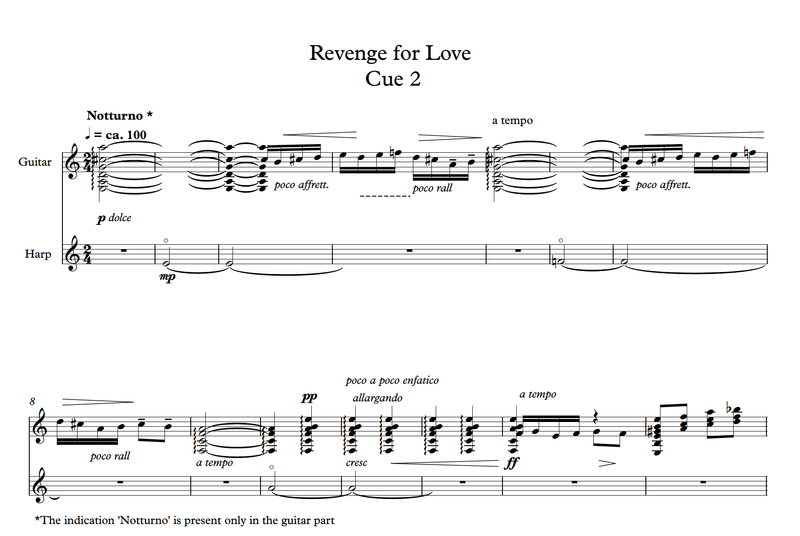*Figure 2 bars 1-15 Cue 2 Revenge for Love*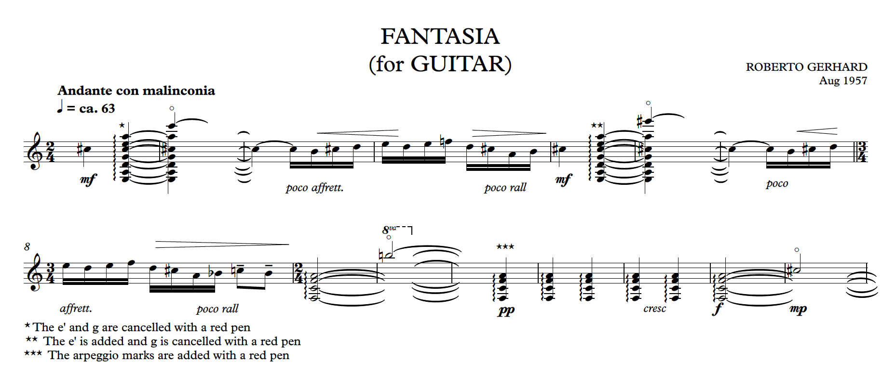Figure 3 bar 1-15 Manuscript Fantasia (Aug 1957)

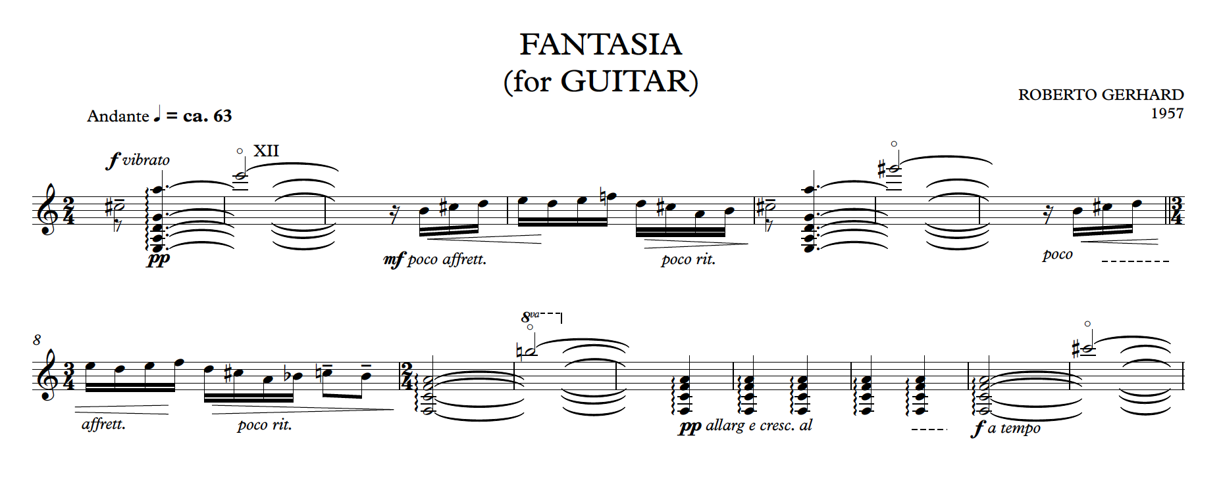Figure 4 bar 1-15 Published edition (Gerhard, 1964)

**Cap 1.4.2 For Whom the Bell Tools**

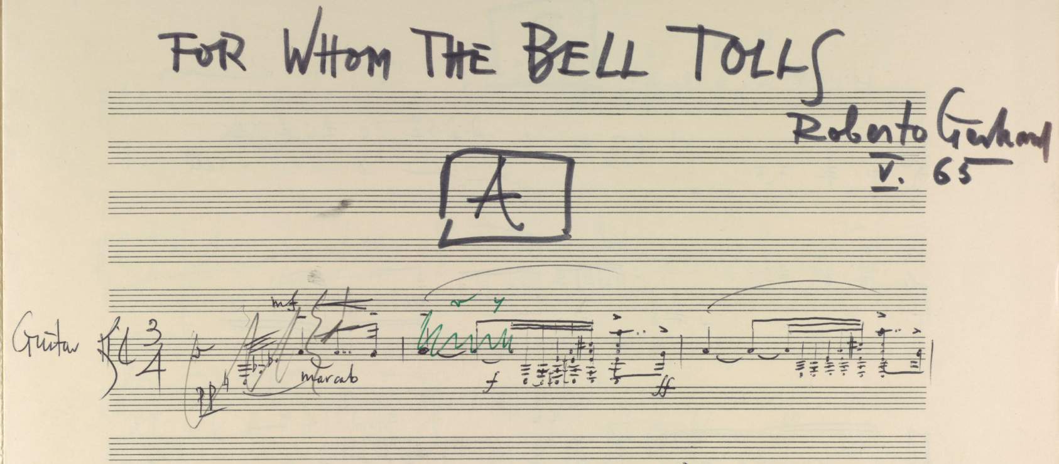*Figure 5 For whom the bell tolls - first page of the manuscript*

As mentioned before, Roberto Gerhard's *For Whom the Bell Tolls* was originally conceived as background music for a television program dedicated to Ernest Hemingway’s masterpiece. The book is set during the Spanish Civil War and tells the story of Robert Jordan, a young American that joins a republican guerrilla unit as a dynamiter with the mission of blowing up a bridge of central importance in the strategy against the Francoist army.

I found very fascinating how Gerhard chose a symbolic use of musical motifs to represent the plot of the book; this intellectual approach allows him to reflect upon the main themes of the book - love, war and death. To do so, he linked specific symbolic elements to elegant quotations from other works and recurrent motifs. In my interpretation, I decided to highlight both the importance of these references and the connection with Hemingway's book. Even if a listener may find difficult to grasp these aspects, they are an essential part of the music, and I believe that if I did not keep them, the composition would have lost value.

Before starting my own version, I outlined a list of priorities that I wanted to follow:

* Use as much material as possible from Gerhard’s music with minimal intervention.
* Preserve and, if necessary, enhance the symbolic links between the book and the music.
* Create a structure that maintains the link with the plot of Hemingway’s book.
* Try to maintain the BBC’s episode subdivision.
* Give a sense of unity and fluidity to the piece.

Of course, I also studied Hemingway’s book trying to understand which parts the composer and the director wanted to reproduce in the television version. Without the scripts, I could only guess the topics of the episodes based on their titles, which were not trivial as the director decided to underline some particular aspects of the story:

**I - Reconnaissance**: Robert reconnoitres the bridge for the first time and then meets the members of the Republican guerrilla unit (mainly Pablo, Pilar and Maria). After meeting the group, he does a second reconnaissance of the bridge.

**II - The moon of May:** It is not easy to identify a specific part of the plot just by reading the title also because the *moon of May* is mentioned twice in the book. By analysing Gerhard's fragment in part II of the manuscript, I linked this title to a section of the book in which some soldiers brag about their aviation.

**III - Verdict on Pablo:** This title refers to Pilar and Jordan’s decision to assassinate Pablo who has become dangerous and unstable. (This plan will eventually fail).

**IV - The Bridge:** The last title is about the final mission, in which the bridge is exploded and the protagonist loses his life.

**The new version**

I divided the composition into four groups named after the four BBC episodes that helpthe audience follow the plot. For the longest and most structured episodes, *I- Reconnaissance* and *III - Verdict on Pablo*, I decided to add subheadings to specific movements to create references that could explain my approach in revising the piece.

I - Reconnaissance: a) The bridge b) Pablo c) Pilar d) Reconnaissance

II - The moon of May

III - Verdict on Pablo: a) Un galán y su Morena b) The bell c) La muerte y la doncella

IV - The Bridge

I also tried to connect the different fragments to create coherent movements, and I decided to minimise my modifications to the material written by Gerhard, partly because I wanted to respect as much as possible the work of the composer and partly because I realised that, just by connecting some fragments, I reached the result I aimed at. In the next paragraphs, I will analyse the structure of the piece and my interpretation of the connections between the plot and the music.

The first episode is divided into four movements that narrate the first part of the book (the first reconnaissance of the *bridge* and the meeting with the members of the guerrilla unit, followed by a second reconnaissance). The motif associated with *the bridge* appears in the first and the last movement of the first episode, *a) The bridge* and *d) Reconnaissance*, and again at the end of the composition. However, each time I introduced some variations. Indeed, in the first movement the motif ends on a suspended chord, while in *d) Reconnaissance* the theme develops into a virtuosic gesture and ends in *a* major chord. This difference reflects Jordan’s emotions: Jordan is full of doubts during his first visit to the bridge, while the music conveys his pride and positivity during the second reconnaissance with the members of the guerrilla, when he becomes certain of the success of the mission.

In *The moon of May,* I combined three different fragments creating an ABA form, in which the A sections are whole fragments, while the B section is a combination of several fragments based on the same musical gesture. The rapid arpeggios of the A sections with their sudden dynamic changes symbolise the planes flying over; on the other hand, the B section has a more march-like style that, in a continuous crescendo, culminates in a rapid *rasgueado*, recalling the sound of a machine gun. The episode ends with some harmonics that were already used in the first episode.

I took two of the titles of the movements of the third episode two titles of the movements of the third episode, *Un galán y su Morena* and *La muerte y la doncella,* from two pieces of Gerhard’s *Cantares* (Gerhard, 1962), a series of songs for voice and guitar, because the compositions share the same main motive.I think that *Un galán y su Morena*, which is the movement in the middle of the composition, represents the love between Jordan and Maria, both because of the title and the melody of the piece. Indeed, Jordan shows his love by trying to make Maria fall asleep and forget the horror of the war; Gerhard expresses this episode by using the melody of a popular Catalan lullaby (Tobalina, 2006), which he previously used in *Cantares*.

*The bell* (in which the sixth string is tuned in *d*) is the darkest and most intense moment of the whole composition. The gloomy atmosphere, the percussions, which stand for the sound of the bells, and the veiled references to *Homenaje pour "Le Tombeau de Claude Debussy"* by Manuel De Falla clearly link the piece to the theme of death. Indeed, this movement seems to foretell the death of Pablo, which is also suggested by the title of the episode. However, in the end, Pablo will be pardoned, and he will partially reconcile with his wife Pilar.

*La muerte y la doncella* conveys the troubled love between Pilar and Pablo, and Gerhard expresses the issues in their relationship by changing the original melody from the *Cantares* and making it fragmented and incomplete.

Finally, the last movement of the first episode portrays the explosion of the bridge and the death of the protagonist. The theme of the bridge reappears but it gradually becomes more and more dissonant until the final explosion of the bridge, represented by three chords in ***ff***. Another important theme is the theme of death that is based on the melodic cell *e*-*f*, an echo of the *Homenaje pour "Le Tombeau de Claude Debussy"* by Manuel De Falla. It first appears in the ostinato of the third movement, *Pilar*,representing the part of the book in which Pilar reads Jordan's hand and foresees the death of the protagonist. The melodic cell *e*-*f* reappears at the end of the composition symbolising the death of the protagonist after the explosion of the bridge. The music, like the book, leaves the listener with a sense of disappointment for the death of the main character and invites the audience to ponder the horrors of the war, always present, even in a successful mission.

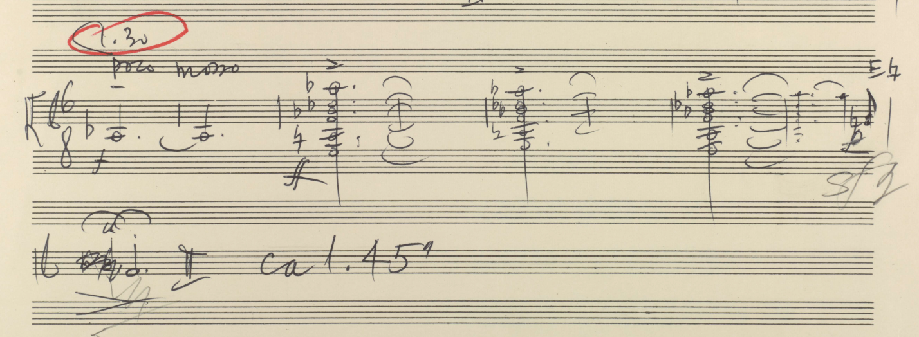Figure 6 *For whom the bell tolls – last section fragment JJ*

**Cap 1.5 Development project: the collaboration between guitarist and luthier**

In the Development project, I investigated, together with two great luthiers, the relationship between guitarist and guitar maker. Gabriele Lodi and Maurizio Foti give special attention to the relationship with the musicians and guitarists who visit their workshop, and they want to meet the needs of the twenty-first century guitarist by developing new resources of tone and colour, while maintaining distinctive characteristics of historical instruments.

The project was divided into four stages:

* Attend the Organology of Stringed Instruments Module (Edinburgh University)
* Test historical guitars owned by different collectors.
* Commission a guitar to Maurizio Foti. In this process, we discussed what kind of sound and type of instrument I was looking for.
* Organise, in collaboration with Gabriele Lodi, two events with concerts and lectures dedicated to deepening the understanding of some aspects of the guitar construction.

The collaboration with Maurizio Foti culminated in the realisation of an instrument that I used in many recordings of my doctorate. Besides following every step of the guitar construction, I exchanged opinions and discussed points of view with Maurizio; hence, before every crucial phase of the construction, I spent days in Maurizio’s workshop to define the details of the guitar. This experience was very important to broaden my knowledge and it gave me the opportunity to understand and discuss Maurizio’s choices for the creation of the guitar.

The two events organised with Gabriele Lodi were dedicated to two important guitar makers, Hermann Hauser (1882-1952) and Francisco Simplicio (1874-1932), who were very interesting figures for my research because of two different reasons. Hermann Hauser represented an excellent example of a successful collaboration between a luthier and a guitarist. Because he developed his most successful model with the help of the Spanish virtuoso Andrés Segovia, learning more about their collaboration was important to understand the evolution of the instrument at the beginning of the twentieth century. Segovia was trying to widen the existing repertoire for guitar through collaborations with composers, and he needed a new instrument capable to support his ideas and express the new music written for him. Hermann Hauser was the luthier that helped him achieve the instrument he had in mind since his new model accomplished the difficult task of reaching the same tone quality of the Spanish masters, while increasing significantly the sustain and the volume of the instrument.

On the other hand, I was interested in Francisco Simplicio because of his close relationship with the Catalan culture, which has been a central aspect in different projects of my doctorate[9]. Simplicio created many connections and collaborations with other artists from Barcellona and he can be considered as an exponent of the *Catalan art nouveau*. His aesthetic taste rich of decorations may be considered by some as a mere display of his craving skills but I think it should be seen as part of a broader artistic movement that involved Catalan painters, sculptors and architects. Even the sound of his guitars, always evocative and expressive, seems to me his attempt to express through music the poetry of the Catalan composers of the first part of the twentieth century.

**Cap 1.6 Supplementary studies**

In addition to the artistic projects, as part of the doctoral programme, I attended a few taught courses for a total of 120 SCQF. The purpose of the supplementary studies was to broaden and deepen my artistic practice, developing and learning skills necessary for my research.

I attended the following supplementary studies:

* 2nd Study Composition 1 – 10 credits (2015/2016)
* 2nd Study Composition 2 – 20 credits (2016/2017)
* Organology of Stringed Instruments Module (Edinburgh University) (2015/2016)
* Negotiated project – Recording of Augustin Barrios’s music on a historical instrument and gut strings (2018-2019)
* Negotiated studies – Federico Mompou complete solo music (2018-2019)

In the first two years, I studied composition with Rory Boyle at the Royal Conservatoire of Scotland. During the course, he offered substantial help to develop my abilities as a composer, in particular on what concerns composition for different ensembles. Thanks to his guidance, I have expanded my knowledge of the main problems of writing for other instruments. In the last year, I have also worked on some guitar music, receiving inspiring observation from a non-guitarist composer.

The Organology of Stringed Instruments Module -- along with the regular meetings with guitar makers like Gabriele Lodi and Maurizio Foti – was of key importance for several projects of my doctorate. The knowledge of the organology characteristics of the instrument allowed me to develop and improve my technique. In particular, my approach to historical instruments has significantly changed: understanding the characteristics and functionality of different instruments – deeply connected to a specific sound aesthetic and created for a particular type of string -- has undoubtedly played a central role in my technique development.

The module was also preparatory to address the organisation of events dedicated to guitar making (part of the development project). In these events, I interacted with many experts, collectors and luthiers. In fact, in order to coordinate the staff, to co-curate the exhibitions and to design the structure of various events, it was necessary to have adequate knowledge of the subject.

The negotiated project was centred on the figure of the composer-guitarist Augustin Barrios Mangoré (1885 – 1944). The Paraguayan virtuoso is undoubtedly one of the greatest guitarists and composers of 20th century; he wrote more than 158 original works in addition to over 100 transcriptions for the instrument. Agustín Barrios Mangoré was also the first prolific recording guitarist; from 1910 to 1942 he recorded in studio 59 tracks.

In the project, I studied his music with the aim of learning how to perform with historical guitars and gut strings. Thanks to *TouchTheSound project* (www.touchthesoundproject.com) I had the opportunity to use original instruments by Domingo Esteso (1930) – Barrios used an instrument of the same guitar maker in many of his concerts--.

In the project, I experimented the use of gut strings which required a drastic change in my approach and technique. Furthermore, observing the approach of Augustin Barrios as a performer of his music was very interesting for the broader context of the doctorate. Barrios in his interpretations do not merely reproduce what is in the text, but he lived the execution of the piece as a moment of recreation. His works are dynamic compositions that while maintaining their identity seem to change with every performance. In addition to its recording, also the various autograph sources of the pieces show significant differences.

In the project, I recorded *La Catedral* and *Prelude in a minor*

The negotiate project consisted of the recording of the complete music for solo guitar by Federico Mompou (1893 – 1987). The project output was the publication of an album that included – in addition to Mompou’s music -- also Roberto Gerhard's compositions and two folksongs arrangements by Emilio Pujol. The album *Mompou & Gerhard complete solo guitar music* was released by the record label *Brillant Classics*.

I recorded this music with a Francisco Simplicio’s guitar (1931). The guitar made in Barcella was perfect for this project dedicated to the Catalan composers. With its intense and raw sound, it has been for me the best companion through the exploration of Mompou and Gerhard’s poetic atmospheres and dissonances.

This project was particularly appealing because it involved the study of the *Suite Compostelana*, a composition dedicated to Andrés Segovia. In defining my interpretation, I studied both the manuscript and the revised version by Andrés Segovia. After a careful study of the two texts, I decided to base my interpretation on the revision of Andrés Segovia, adding some elements from the autograph. The approach differs from the one I adopted in the artistic project 1 about the music of Thomas Wilson, where I based my performance edition mainly on the manuscript.

Cap 2 The Role of dedicateeS

This chapter explores different aspects of the role of a dedicatee and first performer of a composition, and it makes specific references to the collaborations I created during my doctorate.

The level of involvement of the dedicatee during the creative process, the type of collaboration and the backgrounds of the two artists are important factors that can influence significantly the role of the dedicatee. The dedicatee can be highly involved in the compositional process and her/his role may not be merely confined to the performance of the piece. I will analyse different aspects of the dedicatee’s role by dividing into phases the collaboration between the performer-guitarist and the composer:

* *Before* the start of the composition.
* *During* the compositional process.
* When the piece is finished but requires *revision*.
* When a composition has reached its *final* *stage*.

The dedicatee may be involved in some or all the phases of the creative process.

**Cap 2.1 Before the start of the composition**

The collaboration can start before the genesis of the work when composer and performer get to know each other’s opinions and ideas and discuss future work. In what follows, I will describe two different types of role that the guitarist can take on at the earliest stage of collaboration. The first approach refers to the case in which the collaboration involves a non-guitarist composer, while the second investigates the role of the dedicatee in a broader context.

**2.1.1 The dedicatee as a medium between the composer and the guitar**

When a composer does not have previous experience in writing for the guitar, the dedicatee may not only give stimuli or suggestions but rather act as a *medium* between the composer and the instrument. In the initial phase, he may guide the composer in her/his first approach to the instrument showing its potentials and limitations and helping her/him discover its repertoire.

Based on my experience, I think that the initial step of the collaboration with a non-guitarist composer should be further divided into four phases (not necessarily consecutive):

* **Playing for the composer:**   
  The performer plays selected compositions to show the sound and the potential of the instrument.
* **Showing the repertoire:**   
  The dedicatee helps the composer get acquainted with the existing repertoire of the instrument.
* **Giving advice on writing for the instrument:**   
  The dedicatee gives tips, instructions and restrictions that can help idiomatic writing.
* **Encouraging creativity:**   
  The guitarist helps the composer find a compositional approach through which she or he can freely express her/his creativity within the idiomatic writing restrictions.

When I collaborated with Raffaele De Giacometti, the first step of our cooperation began with a meeting in which I played some compositions and explained certain guitar techniques. The composers asked me to try some melodic elements and particular techniques because he was keen to explore specific sonorities. Thanks to Raffaele’s curiosity, our initial meetings became interactive moments in which we looked into the potential of the instrument together. At the end of the meetings, I gave Raffaele examples of scores and recordings of guitar compositions written by non-guitarist composers. I tried to provide him with a heterogeneous set of examples by selecting three pieces written in a more traditional language and five that included unconventional techniques; by doing so, I wanted to show Raffaele how the instrument can perform a variety of compositional qualities: homophonic, polyphonic, contrapuntal, rhythmic, percussive and harmonic. The list of examples can be found below.

|  |
| --- |
| Traditional languages:   * Toru Takemitsu (1930-1996): In the Woods: 3 Pieces for Guitar * Benjamin Britten (1913-1976): *Nocturnal After John Dowland*, op. 70 * Federico Mompou (1893-1987): *Suite Compostelana*   Unconventional languages:   * Helmut Lachenmann (b. 1935): *Salut für Caudwell* * Julian Anderson (b. 1967): *Catalan peasant with guitar* * Luciano Berio (1926-2003): *Sequenza XI for guitar* * Hans Werner Henze (1926 – 2012): *Royal Winter Music. First Sonata* * Alberto Ginastera (1916-1983): *Sonata for guitar*, op.47 |

Also Andrés Segovia adopted in many collaborations the idea of familiarising the composer with the guitar by indicating selected compositions. The Italian composer Mario Castelnuovo-Tedesco (1895-1968) indeed notes:

*"One day in 1932, my wife Clara, being in Venice, found herself travelling on the same ferry as the great Andrés Segovia. The Maestro spoke to her about his wish that I would compose for the guitar. I wrote expressing my desire to write something for him, neither knowing the instrument nor how to compose for it. In return, Segovia sent me two pieces which demonstrated the guitar's capabilities: Sor’s Variations on a Theme of Mozart, op. 9, and Ponce’s Variations on Folia de España and Fugue.” (Otero, 1999 p.48)*

The next two phases of the compositional process (assisting the composers in idiomatic writing and prompting them to pursue their own approach) may be at odds if they are not finely balanced. During my collaborations, I preferred the composers to feel free to explore the guitar, and I limited my indications to showing the range of the instrument and some polyphonic and technical constraints. I encouraged them to think out of the box and to push the boundaries of the instrument. This approach was also important to strengthening the collaborations during the following phases of the creative process.

Besides the dedicatee’s advice, non-guitarist composers can also rely on several resources about idiomatic writing that have been recently published (Bonaguri, 2015) (Godfrey, 2013) (Josel and Tsao, 2014). Nonetheless, many composers prefer a direct approach with the instrument; for instance, Thomas Wilson[10] and Julian Anderson have tried to play the guitar themselves (Anderson and Zanon, 2017). Although this approach helps the composer acquire a deeper understanding of the practicalities of the instrument, it requires a long commitment and cannot guarantee an exhaustive overview of the technical and expressive potential of the guitar.

It should be noted that a considerable part of the twentieth-century guitar repertoire was written without basic knowledge of the instrument and through collaborations with the guitarists. Excellent examples are the composer Mario Castelnuovo-Tedesco who wrote in a letter to Mario Gangi (1923 –2010) that he was not able to play even the open strings of the guitar (Carfagna and Del Greco, 2016, p.22), and Terry Riley who collaborated with the American guitarist David Tanenbaum:

*“I wrote Ascension at the piano knowing that I would be able to collaborate with you. That was an important decision. Because you were able to provide technical knowledge on the guitar, I was able to work solely on musical ideas. Unless a composer is all-knowing and all-seeing, it's a great way to work: you can pool knowledge.”* (Riley, quoted in Tanenbaum, 1995, p. 11)

**2.2.2 Giving the composer stimuli for the creation of the piece**

When two artists start collaborating, their backgrounds, previous projects and ambitions can be conveyed to their relationship. In this way, their conversations, meetings and exchanges of artistic activities become the means to fuel the following steps of the collaboration.

An example of this is my collaboration with the composer Kai Nieminen and the performers Andrea De Vitis and McNeill Savaloni Duo, a collaboration that started before the compositional process. Before the long compositional process of *Shades…Fantasia-Sonata* began, Kai and I broadened our mutual knowledge through weekly Skype calls, and our conversations represented a significant step forward in our collaboration. Initially, we just discussed and shared our musical ideas, we did not have a specific goal; however, we ended up devising a new ambitious piece. During our chats, we started examining and discussing the character of the piece and the specific tuning (Eb Ab d g bb e’), and we kept influencing one another’s ideas. Kai eventually also asked me to be involved as a dedicatee, and I shared with him my personal approach to the instrument.

Similarly, in the case of *Dida's reminiscence*, commissioned by the Paganini Festival in Parma, and of *Moon*, written for a concert at the St Magnus Festival, the first discussions about the pieces took place well before the compositional process. As both pieces were commissioned for specific occasions, the dedicatees gave me some restrictions and guidelines related to both their needs as performers and the specific performances. These limits became a source of inspiration and introduced new elements to take into account. Moreover, Sasha and Andrea were excellent advisors, and they kept encouraging and motivating me.

As a composer, I consider the act of composing as the moment in which I establish through my music a personal communication with the artist I am writing for. I started all the pieces I composed in my doctorate by listening and talking with the musicians mainly because I wanted to get to know their musical vision, personality, technique and musical approach, and not only because I wanted to understand their requests. Thus, the dedicatee also plays a passive role, becoming a source of inspiration to the composer. Being a performer myself, my approach is also spurred by the curiosity to discover different visions from mine.

**Cap 2.3 During the compositional process**

During the compositional process, the role of the dedicatee can vary mainly depending on the level of involvement the composer requires. When a composer prefers to consider the act of composing as an intimate and solitary process, the role of the dedicatee is marginal and basically limited to supporting the composer in specific cases, for example when she or he doubts the feasibility of certain passages or needs to reconsider the limitations set at an earlier stage. In other circumstances, the composer may need a more interactive relationship with the guitarist, sending notes and drafts and asking for feedback. In addition to the feasibility check of some passages, the composer may ask for greater involvement by inviting the musician to suggest more idiomatic solutions or by asking the dedicatee to improvise some parts in order to explore new idiomatic compositional possibilities.

I was involved in interactive collaborations with the composer Kai Nieminen, and the musicians Sasha Savaloni and Leonardo De Marchi. Indeed, the dedicatees interacted frequently, tested new material and explored techniques or passages involving unconventional techniques. As a result, they had a substantial impact on the pieces.

A very similar process was followed by Laura Snowden during her collaboration with the composer Julian Anderson for the piece *Catalan peasant with guitar*.

*“Julian Anderson and I met regularly throughout the process, which is how he prefers to work,” Snowden says. “He might bring a particular series of notes, which he’d ask me to play in different ways or even improvise around. I was really struck by his acute ear for timbre, and his ability to produce truly inventive and authentic ideas while considering the practicalities of the guitar. “* (Snowden, quoted in Wassily, 2016)

Despite the significant help and participation of the dedicatee, the responsibility for the content of the score is entirely on the shoulders of the composer, and this responsibility makes the composer the only author of the piece[11]. However, there may be cases in which this responsibility and, therefore, the authorship are shared between two or more people.

**Cap 2.4 When the composition is finished but requires revision**

When the composer thinks that the piece is complete, an intense collaboration with the guitarist begins in order to revise the composition; this process is particularly important when the compositional process has not been thought directly on the guitar. The revision phase can be more or less complicated depending on the piece. Indeed, it can be very challenging for a dedicatee who needs to balance the intention expressed by the notation, practical problems in the realisation of the music, her/his own techniques, expressive sensitivity and the context in which the piece will be played. This negotiation phase will be further discussed in the next chapter, *Revision as Negotiation.*

When adapting the text to optimise its realisation on the instrument, the fingering plays a central role as it influences the interpretation of the score, as Richard R. Knepp notes in his work on the Andrés Segovia - Manuel Maria Ponce (1882-1948) collaboration:

*“The research illustrates that, more than re-voicing chords, more than altering placement of dynamics within a score, more than adding colorful programmatic titles, Segovia’s true collaborative influence is found within his unique approach to fingering music on the guitar.”* (Knepp, 2011)

Sometimes, when the guitarist gives a piece back to the composer after revision, the composer may have to rethink and rewrite certain passages or even the entire composition. The composer can decide to rewrite for different reasons; for instance, she or he may decide to rethink a part of the piece after listening to it, or after understanding the challenges in its realisation. or because of a specific request from the guitarist who failed to find effective solutions while revising the piece. I encountered also another reason when I collaborated with the composer Marco De Biasi on *Vento d'Inverno*. Marco De Biasi is a composer but also a virtuoso of the instrument, and, for this reason, it is not surprising that *Vento d'Inverno* showed an excellent idiomaticity since its first draft. The process of fingering was an opportunity to compare our techniques and led to marginal changes. The composition was performed on July 10 2016 at the National Gallery of Edinburgh, when, despite the warm appreciation of the audience, I realised that the piece sounded like missing a proper conclusion, a feeling that was also shared by Marco. After the first performance, I suggested him add a final coda in order to give a more conclusive ending to the piece. After a few weeks, Marco sent me a new version with a coda that changed the balance and the structure of the composition and provided a sense of completeness. Then, we went ahead with the publication and the recording.

**Cap 2.5 When a composition has reached the final stage**

Working on the interpretation of a piece for its first performance can be an exciting time for both the composer and the interpreter because in interpretation it is finally realised the intention piece. The interpretation phase brings together the genesis of the work and its final presentation to the audience, and it can be very productive when both the creator and the performer participate in defining the details of the interpretation.

When I was the interpreter of a piece, my meetings with the composers before the first performance were incredibly helpful, and they greatly influenced the final result. I went beyond the score and, together with the composers, I tried to grasp the deepest meaning of their work by shaping my point of view around their own view of the score.

Experiencing the interpretation phase as a composer made me see the piece under a new light. I composed and performed *Im Nebel* prior to my doctorate but, during my studies, I worked again on the composition with Sean Shibe, the dedicatee of the piece. During our collaboration, we met several times to discuss the composition and explore new ideas, each meeting was a discovery. In the end, Sean’s execution diverged from some of the indications I made at the time of publication, and, at first glance, his interpretation seemed to differ from my compositional vision. However, the poetic and tense effect his interpretation achieved was exactly what I was looking for. In a sense, I felt that Sean’s version was closer to my idea thanks to the differences he introduced.

I think that the musical text is an intermediary of something deeper that is revealed in unique ways through the process of interpretation, and I believe that a performer can diverge from the notation while keeping a high degree of fidelity to this deeper meaning; as Richard Rodney Bennet (1936-2012) says:

*'Julian [Bream] does some things in the guitar Concerto that are not in the score,' he said. For example, he does a rasqueado that I didn't write. But he likes the idea of playing it his way and he was determined to do it... Julian's performance may be eccentric, but it has depth and poetry. John Williams played the Concerto extraordinarily, with no difficulty at all. He is a marvellous player but — I even hesitate to say this — John's performance didn't have the poetry of Julian's.'* (Bennett, quoted in Tosone, 1996, p. 12).

Cap 3. Revision as Negotiation

When a composer is not familiar with the guitar, she or he may compose the music without carefully considering neither the limitations nor the strengths of the instrument. This can also happen when expert guitarists prefer not to have their creativity constrained by practical technicalities during their compositional process. In both cases, the process of *revision* becomes crucial to adapt the composition to the instrument. This chapter analyses the main characteristics of this pivotal phase of the collaboration between composer and guitarist by drawing inspiration from the approach adopted for translations by the Italian writer and linguist Umberto Eco in his book “Dire quasi la stessa cosa” (Eco, 2013).

According to Eco, translating first requires an interpretation of the different levels of meaning of the text. This interpretation should shed light not only on its content but also on the cultural context and the *possible world* (in Eco’s words) that the text represents. The role of the translator is to *preserve* as much as possible all these different meanings with the aim of creating a *functional equivalence*. As Eco says:

“Instead of speaking of equivalence of meaning, we can speak of functional equivalence: a good translation must generate the same effect aimed at by the original. Obviously this means that translators have to make an interpretative hypothesis about the effect programmed by the original text, or, to use a concept I like, to remain faithful to the intention of the text. Many hypotheses can be made about the intention of a text, so that the decision about what a translation should reproduce becomes negotiable.” (Eco, 2004, p. 56)

Although I know that the work of a translator and the one of a guitarist-reviser are completely different for objectives and methods, I believe that some of the concepts proposed by Eco can be useful to see the process of revision in a new light. In the next section, I will introduce the concept of *negotiation* to define the three main phases of the revision process; in the session 3.1.4, I will show how Eco’s ideas of *losses* and *compensation* can also fit into this process.

**Cap 3.1 The concept of negotiation**

Before investigating the revision phase, I should first clarify that it is not an objective or a standardised process. On the contrary, it always requires the guitarist to take a stance and choose from the wide variety of possibilities that arise from the different interpretations of a score and the multiple ways in which the same music can be played on the guitar. Every choice implies a subjective decision, which inevitably determines a degree of *infidelity* from the original text. Despite the negative connotation of the word, *infidelity* is often appropriate and necessary as I will explain.

The reviser plays a crucial role in preserving the intention of the author and the artistic spirit of the composition, i.e. in creating a functional equivalent of the original piece through her/his revision. To this aim, the concept of *negotiation* is a key element of the revision process as it comprises all compromises and decisions that the reviser must make to balance the *trade-off* between the fidelity to the original text and the practical problems in realising it on the instrument. This process may also be supported by the author herself/himself. In this case, all revisions and negotiations can be approved directly by the composer, significantly relieving the reviser from the burden of choice.

In order to better understand the concept of *negotiation*, it is useful to divide the process of revision into three different phases:

1. Interpretation of the source text.
2. Identification of problems in the realisation on the instrument.
3. Compromise between different elements.

**3.1.1 Interpretation of the source text**

When revising a score, an interpretation stage is necessary because, if the revision’s aim is to remain faithful to the *intention of the text*[12] (as Eco suggests for the translations), the reviser must hypothesise what this intention may be. In this section, I will outline some guidelines to interpret the text that will help the guitarist hypothesise which aspects of the composition should be preserved. To interpret a score, the guitarist must not define a unique way of understanding it – which is something that I actually regard as nearly impossible or even pretentious. I will explain what the interpreter should take into account and I will suggest a potential way to proceed with the interpretation.

The reviser needs to look beyond the textual and graphical content of the music and try to interpret its intention; to achieve this, she or he can get support from three main sources. The first one is the text itself: All the components of the score are meant to provide information in order for the performer to realise the desired musical effect. The second source is the *cultural context* in which the piece was composed. To interpret a composition, focusing only on the notation is not enough, the guitarist needs to contextualise it in a certain time and space, as well as take into account the personality of the composer. Indeed, we cannot consider the musical text as something independent from the composer and the cultural context in which it was generated. The third source is the composer herself/himself, who can provide explanations and interpretations of the piece.

In Eco’s words, *a text is the manifestation of a substance* (Eco, 2004, p.28). In the case of a musical text, the substance is a very complex organism. To describe the substance of a score and dissect its complexity, I will introduce the concept of *levels of substance*.

While assessing internal (the text) and external (the cultural context and the composer) sources, the text can be seen from different *levels of substanc*e that focus on certain aspects of the music. These levels vary significantly depending on the context and the musical language of the composition; therefore, an important step in the interpretation process is to identify which are the best substantial levels to interpret the score. To clarify this concept, we can consider the following example. If we had to analyse a nineteenth-century sonata by a German-composer, the most interesting levels of substance would probably be the harmonic level, the melodic level, the formal level and the dynamic level. Obviously, our approach would be quite different if the composition was written in the first half of the twentieth century with a twelve-tone technique. In this case, to describe the notation content of the music, we would need to look at other levels of substance, such as levels related to the specific twelve-tone technique used by the composer.

After observing the text from the perspective of different substantial levels, the interpreter needs to correlate all her/his observations. In fact, I realised through my experiences that I was able to discover the *non-negotiable aspects* of the pieces only by linking and finding connections between levels. By *non-negotiable aspects*, I meanthe ones that we should be preserved during the revision in order to convey the (interpreted) *deep intention* of the text.

To summarise, the substance levels could be simply defined as a means to observe and describe the music. By analysing and linking different levels of substance, the reviser can identify and decide what her/his revision should ideally retain.

**3.1.2 Identification of problems in the realisation on the instrument**

The guitar is a complex instrument with specific weaknesses and strengths. For this reason, a second important step of the revision process is recognising the difficulties in performing the *intention of text* on the guitar. At this stage, the reviser should not just make a “test of feasibility” of the written content but she or he should take responsibility for identifying obstacles that may hinder the performance in relation to the interpreted *intention of text* and its *context of use*.I mean by context of use those specific goals of the composition that may add additional constraints for the reviser. For instance, if the revision is meant to create a publication for educational purposes, the reviser will be expected to adapt the original composition by taking into consideration the technical and musical level of the students to address. If the same composition is meant to be revised for a *première* at the Wigmore Hall in London, the reviser will be expected to adopt a completely different approach.

**3.1.3 Negotiation**

After the interpretation phase and the identification of the difficulties related to the instrument, the reviser must negotiate potential solutions. What should the reviser take into account in order to put forward a proposal and, eventually, to make decisions? I have listed below the most important elements the reviser should evaluate:

1. The interpreted intentions of the text (analysed on the basis of several levels of substance).
2. The technical and expressive potential of the instrument.
3. The *context of use* of the revised piece.
4. Other negotiations during the revision.

The first and third themes have been already discussed in the context of the first two phases of the revision process. I will now focus on the other types of negotiation that can happen while revising a score.

Any decision made during the revision process can have an impact on previous and future decisions as they are all somehow connected, I will refer to this type of impact as the *ripple effect* of the negotiation. When making decisions, it is crucial to take into account the ripple effect both to ensure consistency in the final outcome and to increase the efficiency of the process.

I would also like to mention another aspect that has a relevant impact on the revision, although it will come into play only later on: the artistic sensitivity of the reviser. It is widely recognised that revisions by renowned virtuosi such as Andrés Segovia and Julian Bream are strongly influenced by their poetics and musical taste. Is it common that negotiations are influenced by the reviser’s sensitivity? I think that it is indeed very common, actually, to a certain degree, I believe this is always the case. Indeed, even if a musician does not want her/his artistic sensitivity to affect the final text, inevitably she or he is already influencing the negotiation through the revision process when she or he shares her/his personal opinions.

To conclude, I will go back to Umberto Eco and his final suggestions for a *faithful* translation:

* Interpret with passionate complicity.
* Engage in the selection of what is for us the deep sense of a text.
* Embrace the goodwill that prods us to negotiate the best solution for every line.

I think that these pieces of advice, combined with the ability to define problems and find solutions, should be followed also by the reviser in her/his approach to the source text. In this way, the reviser will honour the work of the composer and respect who will study the text.

**3.1.4 Losses and compensations**

So far, we have discussed the dynamics of “revision as negotiation” through three different phases. In this section, I will propose an adaptation of the Eco’s concepts of *losses* and *compensations* so that they can be applied to the revision of a composition. As I will explain, this adaptation can be particularly useful for the reviser to better understand the impact of his revision work on the original text.

As I have already mentioned, the process of revision and negotiation always implies some infidelity. First, this is due to the fact that the revision is based on an interpretation of the original text that is never, by definition, fully objective. Second, sometimes the guitar itself does not allow to reproduce the exact intention of the original text. The resulting infidelity can be examined in terms of losses and compensation.

The concept of *losses* refers to the aspects of the interpreted *layers of substance* that were not retained after revision. There are different types of *losses*:Losses that do not affect the deep intentions of the text (as interpreted by the reviser), and losses that instead distort the intentions. The first can be considered as normal steps of the revision process, while the latter can give rise to ethical and artistic concerns. In the case of losses that significantly alter the initial intent, the reviser should include in the revised version the modifications next to the original text, giving the performer the opportunity to easily get back to the original version.[13]

The concept of *compensation* refers to any addition that the reviser makes to preserve the *functional equivalence* of the original text. By adding a compensation, the reviser aims to offset a loss and retain the interpreted intention of the text. We could say that a compensation is a white lie to remain faithful to the intention of the composition (as interpreted by the reviser). The good-will of the revisor to remain faithful to the intention of the text is a crucial distinction between the so-called artistic re-writing and any other artistic license.

During their collaboration, reviser and composer can reach agreements on losses and compensations (Eco, 2004), even major losses could be considered acceptable and “authentic” if the author approves them.

**Cap 3.2 A case study: In Absentia Essentia**

I will now illustrate my revision of the Raffaele De Giacometti’s piece *In Absentia Essentia* that I carried out by applying the concepts described in the previous sections. This revision was part of a broader collaboration between Raffaele and myself that started in September 2015. At that time, we just started our studies at the Royal Conservatoire of Scotland and we soon realised we would have liked to work together, so *In Absentia Essentia* represented an opportunity to establish our productive collaboration.

*In Absentia Essentia*, initially titled *Saudade*, was not originally conceived as a piece for guitar since it started as an elaboration of a transcription of a piano improvisation. Raffaele later decided to use this improvisation to compose a guitar piece, as he explained in the program note of the first performance[14]: *“After meeting Marco Ramelli, to whom the piece is dedicated, I thought that the ideal instrument to express my ideas would be the classical guitar, not only for the intimate timbre required by my piece (as suggested by the title itself), but also for the nostalgic character that such an instrument is magnificently able to express.”*

I received Raffaele’s first version of the piece in September 2015, and, as with most pieces originally composed for a different instrument, I realised that a process of revision was required to play the composition on the guitar. In fact, while the poetic idea and the polyphonic density seemed to be compatible with the guitar, I needed to address some technical issues. What follows briefly describes the three phases of my revision and explains how Raffaele and I arrived at the final outcome.

**3.2.1 Interpretation: Discovering the music**

The first phase of the revision started with the interpretation of the piece. As explained in Section 3.2, the main aim of this phase is to identify the substantial levels that can be used to interpret the *deep intention* of the music. I chose four substantial levels that I deemed particularly appropriate to understand Raffaele’s music: 1. the Poetical level, 2. the Musical content level, 3. the Structural level and 4. the Sonority level. The Poetical and Sonority levels refer to the expressive ideas of the composition, while the Musical content level and the Structural level refer to musical components. However, each level cannot exist on its own because it is strictly interconnected with the others. Hence, some interpretations can be applied to multiple levels but, for the sake of brevity, I will describe them only in reference to a certain level.

1) Poetical level

*In Absentia Essentia* is a composition that expresses the emotional world of melancholy with delicate and ethereal atmospheres. The incessant repetition of the obstinate is countered with melodic leaps that describe a variety of emotional states, such as loss, sadness, acceptance and serenity.

I first inferred the poetic idea of the piece by looking at the music score. The title of the first version of the composition, *Saudade*, provided me with the first clue of the poetic atmosphere of the piece. Indeed, *Saudade* is a feeling combining melancholy and nostalgia that is considered common among Brazilian people. However, the piece does not have any explicit connection with Brazilian music or culture and this was one of the reasons why Raffaele eventually decided to change the title to *In Absentia Essentia*[15] during the revision process.

I then refined my interpretation of the piece by keeping discussing with Raffaele throughout the process of revision; thanks to our collaboration, I was able to discover more about the *context* in which the piece was composed. *In Absentia Essentia* was conceived by Raffaele during an improvisation driven by a deep sense of melancholy, and some elements of this spontaneous creation are still recognisable in the final composition. During that improvisation, Raffaele was sitting on the right-hand side of the piano, as in a four-handed performance, and he used the resonance pedal with his left foot. This particular position, besides helping the composer reach the highest register of the instrument, was meant to represent the idea of someone missing. Also, this unusual way of sitting affected the use of the registers; for example, the lowest notes were used only twice in the whole composition.

2) Musical content level

It is easy to visually recognise at first glance the main elements of the composition as the piece is notated in two staves that clearly separate two main components. In the lower staff, we find an obstinate of two bars that continues unaltered throughout the composition; in the upper staff, there are melodic phrases of different lengths that follow one another. In my interpretation of the poetic level, the obstinate is a metaphor of a natural element that we cannot change, such as, for example, the flow of time; on the other hand, the melodic line, thanks to its sinuosity and variety, represents the human feelings and, in particular, the different emotions connected to nostalgia.

With this interpretation in mind, I knew that during revision I would have been allowed to make small changes to the melodic line, as it is mainly an expression of an improvised language, but I would have been required to keep the immutability of the ostinato. Then, I tried to understand the melodic mode and scales used by Raffaele by *improvising* instead of using a written analysis approach. I improvised starting from the melodic elements and, when I diverged from the original text, I preserved the same modal and expressive context, trying to recreate the same condition of the origin of the composition. My improvisations are not included in the final revision but this process was extremely helpful to immerse myself in the musical language of the piece. This improvisation approach became later on the main way to approach *Ramelliana*, another electroacoustic composition by Raffaele De Giacometti.

3) Structural level

On a structural level, the piece shows a great sense of unity with the dramatic charge well calibrated throughout different sections each having its own internal climax. The macro-structure of the piece is designed on the basis of calculation of golden ratio and Raffaele made clear that, in his opinion, the form was an essential element to communicate the intention of the piece. Therefore, the overall structure and the modulations were non-negotiable elements.

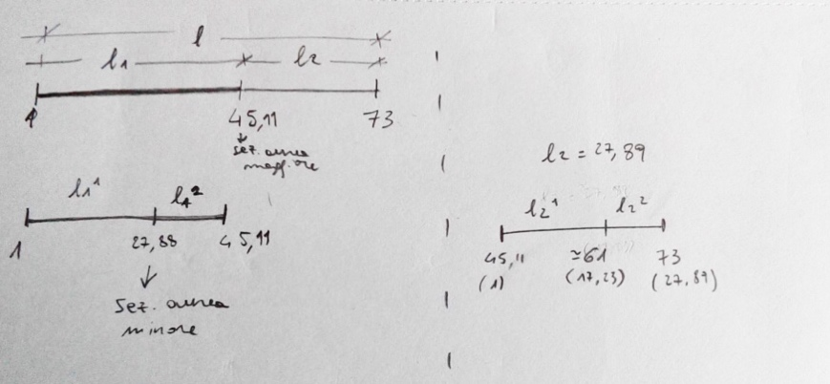

Figure 7 Manuscript of Raffaele De Giacometti with a graphic representation of the structure of *In Absentia Essentia* in relation to the golden ratio.

4) Sonority level

Raffaele regarded the sonority of the piece as one of the most crucial aspects of the composition and he thought it was essential to express his intention. During our meetings, Raffaele helped me grasp the sounds he wanted to create. Resonance was the most important element; thus, I needed to let vibrate each note of the ostinato to create a sonority rich of resonance. By doing this, Raffaele wanted to recreate a meditative and intimate atmosphere that could make the listener enter into a particular state of mind. On the other hand, Raffaele wanted some of the melodic passages, in particular those that go on the highest register, to have a dry and percussive sound that was not aggressive but bright, tense and expressing the feelings of suffering related to nostalgia.

*In Absentia Essentia* also requires a wide dynamic range: from ***pppp***to ***ffff***. The climax passages in particular need a fast and dramatic crescendo that pushes the limits of the instrument, and Raffaele wanted them to be expressed by an unrefined and loud sound showing the dynamic limits of the instrument.

These considerations about sound are also connected to the poetic level because the sound is the way we convey the musical expression. For instance, if we say “stay calm” with a tense voice, we will not communicate the right meaning, and the same happens with music.

**3.2.2 Discovering the obstacle**

The main obstacle to the realisation of the composition was the impossibility of playing the ostinato and the melody at the same time in every passage of the composition as it was initially proposed by Raffaele.

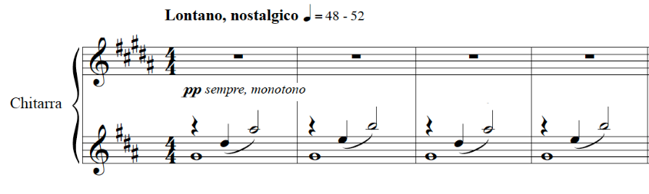

Figure 8 – First four bars of *In Absentia Essentia* before the revision process.

Indeed, the notes that composed the obstinate were mainly *fretted note* (with the exception of the *e’*), which means that I needed both hands to produce them. In addition, the obstinate was in two voices and the lowest one needed to be sustained for the entire bar. These two issues posed serious restrictions on the realisation of the melodic line because I was already using too many fingers. Indeed, whereas on the piano it is possible to play the ostinato with one hand and the melody with the other, this is not feasible on the guitar as the guitarist would need two hands to play them at the same time. However, the independence between ostinato and melody was certainly a core element that I needed to maintained in order to reflect the original intention of the piece; therefore, during the revision process, I had to find a solution to recreate this independence. Although I knew that I would have encountered other obstacles on my way, I was sure that solving this problem was crucial: Without finding a workaround, it would have been impossible to play the composition on the guitar.

**3.2.3 Negotiation**

The moment of negotiation is the phase in which the reviser suggests potential solutions. Once I defined my proposal, I first tried to understand the losses and the necessary compensations, and then I submitted my solution for Raffaele’s approval. I actually rejected many of my initial proposals because I realised they altered too much my interpretation of the text, and Raffaele did not approve others for the same reason. We were looking for a solution that would have allowed me to easily play the ostinato and the melody while keeping the poetry and the sonority of the material written by Raffaele. We also wanted to remain as faithful as possible to the composer’s initial idea and, therefore, we did not want to change either the structure of the piece or the constant presence of the ostinato.

Finding a solution for the ostinato was the starting point of my revision, and I decided to try different tunings to be able to play the ostinato with more open strings. In the end, our final solution was indeed to tune the guitar with the third and fourth strings a semitone up (E A d# g# b e’). This new tuning allowed to play the ostinato with a combination of open strings and natural harmonics, which require the use of the right hand only. Therefore, it was possible to play the melody keeping it independent from the ostinato.

The revised text is just one of the possible solutions to the problem but, for us, it is the best compromise between the interpreted intention of the text and the limitations of the instrument. Although other solutions allowed the realisation of the notes on the guitar, they were not representative of the character and sonority of the composition.

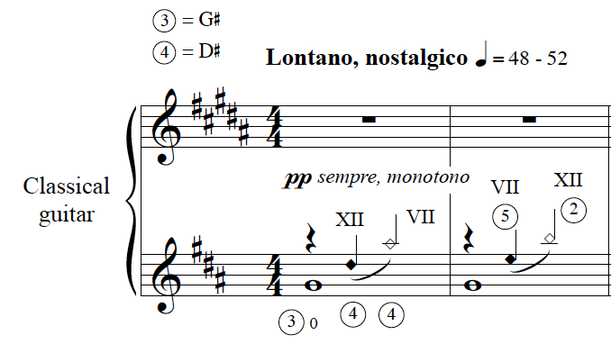

Figure 9 - First two bars of *In Absentia Essentia* after the revision process.

However, our new tuning increased the required technical level and made the piece a real challenge for the performer. Thus, we had to amend some bars to make them easier to play and we changed some almost impossible passages to help the performer.

Although it was not possible to recreate the visual representation of loss of the first piano improvisation, the new tuning of the guitar inspired further poetic interpretations. Indeed, the revised text highlighted different roles for the strings:

* The first two strings were used to play the melody. Their role was to express the different emotional states of nostalgia.
* The third strings g#, which was repeated at the beginning of each bar, conveyed the idea of time.
* The bass strings, used in the ostinato as harmonic (so without the fundamental component of the sound) were an expression of the ethereal presence of a missing person.

Despite our willingness to remain faithful to the score, we had to add some elements. However, I think that it is important to apply the idea of *faithfulness* not only to the final result but mainly to the revision approach. The *faithfulness* can be identified in the reviser’s attempt to use all her/his abilities to carefully interpret the score and to find solutions to realise it on the instrument. The good-will in researching the intention of the music and exploring the potential of the instrument determines the quality of a process of review, and this dedication, if true and aware of the limits of the process, will be reflected in the final review.

Conclusion

References

Anderson, J. and Zanon, F. (2017) *Catalan Peasant With Guitar | Julian Anderson Interview - YouTube*. Available at: https://www.youtube.com/watch?v=Ic4uyYNrbcY (Accessed: 21 January 2019).

Argyris, C. and Schön, D. A. (1974) *Theory in practice: increasing professional effectiveness*. Jossey-Bass Publishers (Management Series). Available at: https://books.google.it/books?id=2rKfAAAAMAAJ.

Barrett, M. S. (2000) *Collaborative creative thought and practice in music*. Routledge. Available at: https://www.routledge.com/Collaborative-Creative-Thought-and-Practice-in-Music/Barrett/p/book/9781472415844# (Accessed: 12 August 2018).

Berlioz, H. (1844) *Grand traité d’instrumentation et d’orchestration modernes*. Paris.

Bonaguri, P. (2015) *Un chitarrista per i compositori. Osservazioni e suggerimenti sullo scrivere per chitarra*. Ut Orpheus. Bologna.

Carfagna, C. and Del Greco, M. (2016) *Mario Castelnuovo-Tedesco nel carteggio con Gangi e Carfagna (1954-1968)*. Bologna: Ut Orpheus Edizioni S.r.l.

Eco, U. (1990) ‘Interpretation and overinterpretation: World, History, Texts’, in. The Tanner Lectures on Human Values. Available at: https://tannerlectures.utah.edu/_documents/a-to-z/e/Eco_91.pdf.

Eco, U. (2004) *Mouse or rat? - translation as negotiation.*

Eco, U. (2013) *Dire quasi la stessa cosa : esperienze di traduzione*. Bompiani.

Gerhard, R. (1962) ‘Cantares : seven Spanish songs for voice and guitar’. London: Mills Music. Available at: http://catalog.hathitrust.org/api/volumes/oclc/7629672.html.

Gerhard, R. (1964) ‘Fantasia’. Belwin Mills Music ltd.

Gerhard, R. (2000) ‘The composer and his audience (1960)’, in *Gerhard on music: Selected writings*, pp. 11–16. Available at: http://search.ebscohost.com/login.aspx?direct=true&db=rih&AN=2000-55008&site=ehost-live.

Godfrey, J. (2013) *Principles of idiomatic guitar writing*. Indiana University. Available at: https://scholarworks.iu.edu/dspace/bitstream/handle/2022/17541/Godfrey_Jonathan_2014.pdf?sequence=1 (Accessed: 28 June 2018).

Hayden, S. and Windsor, L. (2007) ‘Collaboration and the composer: case studies from the end of the 20th century’, *Tempo*. Cambridge University Press, 61(240), pp. 28–39. doi: 10.1017/S0040298207000113.

Homs, J. (1962) ‘Robert Gerhard’, *Inquietud artística, núm. 27 (novembre de 1962)*, Any VIII, p. 3.

Josel, S. and Tsao, M. (2014) *The techniques of guitar playing*. Bärenreite.

Knepp, R. R. (2011) *Tracing the Segovia Style: Collaboration and composition in the guitar Sonatinas of Manuel Maria Ponce*. ATHENS, GEORGIA. Available at: https://getd.libs.uga.edu/pdfs/knepp_richard_r_201105_dma.pdf (Accessed: 30 November 2018).

Mccutcheon, G. (2010) *Perspectives on Gerhard: Selected Proceedings of the 2nd and 3rd International Roberto Gerhard Conferences Original*.

Otero, C. (1999) *Mario Castelnuovo-Tedesco : his life and works for the guitar*. Ashley Mark.

Sánchez de Andrés, L. (2013) *Pasión, desarraigo y literatura : el compositor Robert Gerhard*. A. Machado Libros.

Tanenbaum, D. (1995) ‘Terry Riley talks about his first guitar piece — “Ascension”’, *Guitar Review*, 103 (Fall)(11).

Tosone, J. (1996) ‘An impromptu conversation with Richard Rodney Bennett’, *Guitar Review*, 106 (Summe, pp. 9–13.

Wassily, T. (2016) ‘Interview with Laura Snowden’, *Classical Guitar*.

Wilson, M. and Griffith, D. (2011) *Thomas Wilson Introit the Light*. Queensgate Music.

Wilson, T. (1972) ‘Coplas del ruiseñor’. Edited by A. Gilardino. Berben.

1. In the letter of June 5, 1972 from Gilardino to Wilson, Gilardino proposed a new solution after the composer rejected a previous one. Initially, Gilardino suggested playing the entire bar an octave lower. On the other hand, Gilardino’s latest solution, which he extensively explained, had only the first voice one octave higher.
2. Joop Biegelaar is a Dutch guitarist. I contacted him on 30 January 2019 and he told me that he lived in Scotland for four years. He confirmed that he worked with composers during that period but he could not recall their names. Probably, he did collaborate with Thomas Wilson on the piece *Antoni Gaudi (pieces for guitar)*. Indeed, on the manuscript there are a few fingerings written in pencil that Joop thought could have been his own suggestions.
3. I could not trace down the exact date the documentary was produced, and I did not manage to get further information about it in neither Wilson’s archive nor the BBC’s archive.
4. Other studies erroneously attribute the piece to incidental music for the radio. Actually, also in the list of Roberto Gerhard's Manuscripts compiled by Richard Andrewes in the Cambridge University Library the piece is titled: *3.65 For whom the bell tolls: incidental music for radio. - Autogr. [1965].*
5. The first concerto version was made by Meirion Bowen and published in 2006 by Tritó. In 2012, the Italian composer Bruno Dozza made an elaboration of the piece for string quartet and guitar.
6. In his book *Robert Gerhard i la seva obra*, J. Homs wrote that Julian Bream did the *première* in 1957 in London. (Homs, 1962, p. 148)
7. In the critical commentary of my performance edition of Fantasia, I explained my personal interpretation of the *Poco Adagio* section. Initially I thought that the first *A* of the section flat, but further reasoning led me to consider that the mistake in the bar is most probably the natural before the second *A*
8. The incidental music *The Revenge for Love* is written for three violins, viola, cello, double bass, percussion, guitar and harp.
9. During my first project, I worked on *Coplas del ruiseñor* by Thomas Wilson, which is an elaboration of a previous piece dedicated to Antoni Guadí. In the fourth project, I worked on the music of Roberto Gerhard, who is one of the most renowned Catalan composers. In addition, in a supplementary study, I recorded the complete solo music by Federico Mompou, a famous Catalan composer.
10. “Tom puts this down to “a certain sympathy for the instrument” and to “checking that the chords were playable” (Wilson and Griffith, 2011)
11. A similar concept is expressed by Julian Anderson in a video interview for GuitarCoop (Anderson and Zanon, 2017).
12. Eco distinguishes between three intentions: the intention of the author, intention of the interpreter and the intention of the text. He argued that, at least for the translation, what should count is the intention of the text. (Eco, 1990, p. 145)
13. For instance, see the revision by Angelo Gilardino of the *24 Caprichos de Goya per chitarra op. 195* by Castelnuovo-Tedesco.
14. *November 27, 2015, Fridays at One series - Stevenson Hall - Royal Conservatoire of Scotland*
15. The new title provides a new layer of meaning and further information on the interpretation of the poetry. The use of the Latin language to express the idea of “*absence of the essence”* gives a more abstract allusion to the feeling of nostalgia and removes any folkloric reference.