**RCS contemporary guitar projects**The composer and the performer: an entangled relationship

Marco Ramelli



This thesis is submitted in partial fulfilment for the degree of DPerf  
at the   
University of St Andrews

Date of Submission

Preface

This thesis aims to give a reflective synthesis of my practical research on the relationship between performer and composer, a collaboration that has been the subject matter of my study and has involved me as a researcher, performer and composer.

My research stands out from the previous studies because it attempts to look at the collaboration between the guitarist and the composer from different perspectives. Indeed, it provides new insight on the topic by experiencing different types of collaborations from different roles; my multi-angled study was possible thanks to various artistic projects where I worked either as a researcher, a guitarist or a composer. This written work outlines my contribution to all these projects and discusses the artistic insight achieved through my program of study.

The thesis is divided into three chapters preceded by a section summarising the characteristics of the collaboration between guitarists and composers in the nineteenth and twentieth centuries. In the first chapter, I present the different artistic projects carried out during my doctorate. Chapter 2 introduces the different roles of the guitarists in their relationship with the composers, while Chapter 3 discusses the process of revision; in both chapters, I will investigate the subjects by using examples from the artistic projects. In the conclusions of the last two chapters, I will draw up two ideas that have been inspired by the artistic projects.

TABLE OF CONTENTS

***Preface 6***

***The context: The relationship between composer and guitarist 11***

***Cap 1 Artistic projects 15***

**Cap 1.1 Thomas Wilson guitar music (Artistic project 1) 15**

1.1.1 Working on the performance edition 16

1.1.2 Discovering the genesis of the work: *Antoni* *Gaudi (pieces for guitar)* 17

**Cap 1.2 Dedicatee's point of view (Artistic project 2) 19**

**Cap 1.3 The composer's point of view (Artistic project 3) 22**

**Cap 1.4 A posthumous collaboration (Artistic project 4) 24**

Cap 1.4.1 Fantasia 26

Cap 1.4.2 For Whom the Bell Tools 30

**Cap 1.5 Development project: the collaboration between guitarist and luthier 36**

***Cap 2 The Role of dedicatee 38***

**Cap 2.1 Before the start of the composition 39**

2.1.1 The dedicatee as a medium between the composer and the guitar 39

2.2.2 Give the composer stimuli for the creation of the piece 43

**Cap 2.3 During the compositional process 45**

**Cap 2.4 When the composition is finished but requires revision 47**

**Cap 2.5 When a composition has reached the final stage 48**

***Cap 3. Revision as Negotiation 51***

**Cap 3.1 The concept of negotiation 52**

3.1.1 Interpretation of the source text  53

3.1.2 Identification of problems in the realization on the instrument 56

3.1.3 Negotiation 57

3.1.4 Losses and compensations 59

**Cap 3.2 A case study: In Absentia Essentia 60**

3.2.1 Interpretation: Discovering the music 62

3.2.2 Discovering the obstacle 66

3.2.3 Negotiation 67

***Conclusion 70***

***References 71***

The context: The relationship between composer and guitarist

Before focusing on the collaboration between composer and guitarist, it is worth considering why this relationship was neglected by non-guitarist composers during the nineteenth century.

At that time, even though the guitar was already popular, composers were not inclined to write for this instrument. One reason may be that it was considered almost impossible for a non-expert guitarist to write for it, as Hector Berlioz clearly states in his Treatise on Instrumentation: "One cannot compose for the guitar well unless one is a guitarist" (Berlioz, 1844).

Why is the guitar such a difficult instrument to write for? This question is of key importance to understand what followed in the next century. The difficulties are linked to some aspects of the structure and the nature of the instrument:

* Guitar tuning: The guitar is tuned in fourths, with the exception of the third major interval between the second and third open strings. This particular tuning makes the composition process more challenging compared to the more comprehensible keyboard and strings fingerboard.
* Polyphonic/monodic writing: The guitar is an instrument that can be used in either melodic or polyphonic compositions; however, it presents considerable limitations in both cases: composers face difficulties in delineating a melodic passage because of the restrained volume and sustain of the guitar in comparison with the more 'melodic' strings and wind instruments; similarly, in polyphonic passages the guitar presents a limited range compared to the keyboard, making idiomatic writing quite challenging.
* Almost every single sound is produced by using both hands simultaneously and only four fingers per hand, raising further limitations as the fingering certainly requires special attention.
* Using the expressive potential of the instrument: Already since the nineteenth century, it was widely accepted that the tone and the possibility of producing different types of sound were the most outstanding qualities of the instrument. The same musical content can be played on the guitar by using different strings, fingerings or techniques, affecting greatly the expression and tone of the musical passage. Practical knowledge of the instrument is needed in order to compose a piece that highlights those potentials.
* Difficult tonal modulation: Modulation is not easy on the guitar, especially in polyphonic writing. This was a great restriction for the composers during the romantic period, where modulation was becoming a central element of the musical language.

In the twentieth century, two closely related factors contributed to the flourishing of collaborations between composers and guitarists. First, towards the end of the previous century, the instrument underwent a rapid development thanks to a new guitar project conceived by Antonio de Torres Jurado (1817 –1892) that quickly spread. Second, the evolution of the instrument is concurrent with the presence of excellent virtuosos who developed new techniques.

However, this change is not the only reason that aroused the interest of composers in the instrument, the new artistic sensitivity emerging between the two centuries played an important role: The poetic and mysterious sound of the guitar - as often described by poets such as Garcia Lorca - perfectly fitted the evocation of an archaic world that attracted the artists of the time. However, the difficulties in composing for the guitar still remained. Composers started being inspired by the sound of the guitar in their compositions but they were still reluctant to write for it. Writing for the guitar was still considered too complicated.

Initially, the guitarist-composer relationship developed as a necessity to overcome the difficulties faced by the composers through complementary collaborations. In complementary collaboration - as presented by Barrett on Vera John-Steiner's seminal book *Creative Collaborations* (Barrett, 2000) - the two subjects share their knowledge and experience filling the gaps of the other. In this case, the guitarist assists the composer in various phases of the creative process, favouring the use of idiomatic writing, which is suitable for the technique of the instrument. Thanks to this, the composer can avoid looking into the technical complexity of the guitar.

Andrés Segovia (1893 –1987) contributed a great deal to spreading the complementary collaboration since, at the beginning of the twentieth century, he planned to expand the repertoire of the instrument by commissioning new works to some of the greatest non-guitarist composers of the time, such as Moreno-Torroba (1891-1982), Mario Castelnuovo-Tedesco (1895-1968), Joaquin Turina (1882-1949) and Manuel Maria Ponce (1882-1948).

After Segovia, in the last century the number of collaborations have multiplied, involving some of the most important guitarists and composers. It is not surprising that every virtuoso after Segovia collaborated with composers to try to widen their repertoire. In addition, the possibility of collaborating with renowned composers was seen by guitarists as a way to establish their position within the guitar world.

By observing all the different collaborations that guitarists and composers have established, it is likely that they are not led only by complementary practices. Collaboration is done because of certain benefits that go beyond complementary needs. The great variety of collaborations can be described by using the three categories discussed in the research of Hayden and Windsor (2007), which was based on a previous work by Argyris and Schon (1974):

Directive: In this category, the score is the central point of the relationship. The collaboration mostly takes place during the interpretation phase, when the composer provides indications on how to play the music.

Interactive: In the interactive collaboration, the composer and the guitarist interact, discuss and evaluate different options either during or at the end of the compositional process.

Collaborative: the composition is basically collective and decisions are often made together. Sometimes, there is no clear hierarchy of roles.

Cap 1 Artistic projects

The Doctorate in Performance is divided into four artistic projects and a Development project. While the artistic projects focus on the main theme of the research, the development project aims is to expand the professional skills of the researcher.

The artistic projects allowed the researcher to experience the collaboration between guitarist and composer from a different point of view. Each project involved a preliminary research phase followed by practical implementation. The outputs of the projects were diverse and included new music, performance editions, audio recordings, videos and reports on collaborations.

The development project focused on the collaboration between composer and guitarist through the organization of two dedicated events in collaboration with Gabriele Lodi, and the creation of a new instrument in collaboration with the luthier Maurizio Foti.

**Cap 1.1 Thomas Wilson guitar music (Artistic project 1)**

In the first artistic project, I investigated the relationship between performer and composer in the context of compositions written in the past century. The research focused on the composition *Coplas del ruiseñor* written by the Scottish composer Thomas Wilson (1927-2001) in 1971 and dedicated to the Italian guitarist Angelo Gilardino.

This project mainly aimed to create a performance edition of the work and to shed more light on the genesis of the piece. My research greatly benefited from the support of Mrs. Margaret Wilson, Thomas Wilson’s wife, who I had the pleasure to meet in September 2015 in Glasgow. Mrs. Margaret Wilson kindly agreed to support my study by granting me access to the personal archive of Thomas Wilson. I examined in detail the following archival items:

* Eight letters from Angelo Gilardino to Thomas Wilson regarding the composition *Coplas del ruiseñor*.
* A trial recording of Angelo Gilardino playing *Coplas del ruiseñor,* which was sent to the composer in an early stage of the study of the piece to receive feedback.
* The manuscript of *Coplas del ruiseñor*,dated December 8, 1971.
* The manuscript of *Antoni* *Gaudi (pieces for guitar),* a composition commissioned by the BBC as background music for a documentary on Antoni Gaudi. (Wilson used some musical material from this composition as a starting point to compose *Coplas del ruiseñor*.)

I carried out an in-depth analysis of this material and made a careful comparison between the manuscript and the published version (Wilson, 1972). The archival research helped me develop a personal interpretation of *Coplas del ruiseñor*,which resulted in the preparation of a performance edition that I have performed and recorded.

The following sections discuss the main aspects of the approach I used while preparing the performance edition, and how the study of the previous composition *Antoni* *Gaudipieces for guitar)* influenced my interpretation.

**1.1.1 Working on the performance edition**

To address the exciting task of preparing my personal version of the performance edition of *Coplas del ruiseñor*, I had to decide whether to edit the manuscript (included in Wilson’s archive) or the published version. After careful considerations, I made the decision to base my performance edition on the manuscript.

By reading Gilardino's correspondence with the composer, I inferred that most of the differences between the manuscript and the published version arose from editorial requests. In my opinion, the missing or modified elements in the published edition --such as phrase marks and some agogic indications --are fundamental elements of Thomas Wilson’s music. As Wilson himself remarked: “Music is a very complicated art and the performer needs as much help as possible, even to the extent of complementary instruction to make it clear to the performer the particular quality of sound that’s required by me. I try to help the performer to realise this” (Wilson, quoted in Wilson and Griffith, 2011).

However, while preparing the performance edition, I did not completely overlook the published version of the piece. For instance, in the only bar that required revision because it was impossible to craft the instrument, I opted for the solution proposed by Gilardino, which was also accepted by the composer[1].

It is worth mentioning that only a few chords in the revision of Gilardino are significantly different from the manuscript, and that these alterations were presumably made by Gilardino to enhance the technical fluidity of the passage. In my version, I kept the chords as they were written in the manuscript but I decided to include the modifications proposed by Gilardino in an appendix. It will be up to the performer to adopt these modifications in case the realisation of the passage turns out to be too complicated.

An essential part of the creation of the performance edition was the definition of fingering. Wilson’s music, in particular in the monodic sections, can be played on the instrument by using a lot of different fingerings. In my interpretation, I tried to enlighten the lyrical aspect of his music. The melodic passages are often played on the same string trying to enhance the expressive intervals of his music.

**1.1.2 Discovering the genesis of the work: *Antoni* *Gaudi (pieces for guitar)***

Studying Wilson's collaboration with guitarists was of particular interest for my research, and *Coplas del ruiseñor* was a very interesting composition to address this matter as I had access to Gilardino's correspondence with the composer. In the letters, it is possible to observe the revision process: Gilardino points out problems and suggests solutions, and the composer accepts, proposes new ideas or clarifies his intent.

The first version received by Gilardino was already well conceived for the instrument, only a few passages needed to be changed, while the rest of the composition was already ready to be played on the instrument. A reason that could explain the idiomaticity of the composition is the fact that Thomas Wilson, despite not being a guitarist, had tried all passages on the instrument in order to validate their feasibility before sending the first draft to Gilardino (Wilson and Griffith, 2011, p302). Another hypothesis is that the composer collaborated with another guitarist before Angelo Gilardino. In fact, the name of the guitarist Joop Biegelaar, written in pencil on the cover page of the manuscript of *Antoni* *Gaudi (pieces for guitar)*, strengthens this assumption[2].

*Antoni* *Gaudi (pieces for guitar)* was written as incidental music for a documentary, and the composer took inspiration from this piece to compose the core musical material of *Coplas del ruiseñor* (Wilson and Griffith, 2011, p340)[3]. *Antoni* *Gaudi (pieces for guitar)* is divided into different movements, whose titles correspond to works of the Catalan architect Antoni Gaudí:

I – Antoni Gaudí

II – Palacio Guell

III – Casa Battlo – Casa Mila

III (2) – Parc Guell

IV – Chapel Guell, Sagrada Familia

The analysis of the *Antoni* *Gaudi (pieces for guitar)* manuscript was essential to develop my own interpretation of *Coplas del ruiseñor*. Although *Coplas del ruiseñor* is a piece composed of only one movement, the manuscript shows that the composer divides the composition into ten sections by using rehearsal marks. Studying *Antoni* *Gaudi (pieces for guitar)* was also the key to better interpreting the musical form of the piece: a journey through Gaudí’s masterpieces in the Catalan city. For this reason, I decided to keep the rehearsal marks in the performance edition.

Following the collaboration between Angelo Gilardino and Thomas Wilson, reading their correspondence, and understanding Gilardino’s approach to the revision was really useful for my study. Also, it was really interesting to notice how editorial reasons may influence the work of the reviser.

Tracing the origin of a composition can be a challenging procedure because composing is not always a linear process but a more complex one that entails second thoughts, changes and influences from external factors. This complexity does not allow to look back at the history of a piece in a purely scientific (absolute) way; instead, we must try to collect as much information as possible and interpret based on our observations.

**Cap 1.2 Dedicatee's point of view (Artistic project 2)**

In the second artistic project, I collaborated with four composers to create new pieces for solo guitar. The aim of this project was to develop my skills in working in close contact with composers and in creating an original repertoire for the guitar.

I decided to collaborate with composers ~~from different countries~~, who use different musical languages and styles, and this heterogeneity was an extraordinary opportunity to challenge my ability to adapt my approach to the instrument.

The five pieces I worked on are:

* Kai Nieminen - Shades… Fantasia-Sonata
* Raffaele De Giacometti - *In absentia essentia*
* Raffaele De Giacometti - *Ramelliana*
* Marco De Biasi - *Vento d’inverno*
* Fabio Selvafiorita - *Prelude I and II*

As I will discuss in the next chapter, the role of the guitarist in the collaboration with a composer can vary a lot. In fact, my contributions changed on a case-by-case basis, depending on the type of collaboration and each specific piece.

I worked in a very interactive way with the composer Kai Nieminen. Despite Kai being an expert guitarist, in the composition process of *Shades…Fantasia-Sonata* he decided not to try the piece on the instrument. This decision was made because we wanted to explore the compositional process without overthinking about the limits of the guitar and, mostly, because we wanted to experience an interactive collaboration between the composer and the guitarist. Our collaboration actually started well before the composition was written. Once Kai finished the first draft, we worked together for a year to further explore the polyphonic and timbre potential of the composition.

In this process, Kai asked me to participate not only by proposing fingerings or alternative solutions but also by suggesting new compositional ideas or changes in the score. During our continuous research, we created a sort of “*joint venture”* in which we tried to investigate together the potential of our instrument without setting well-defined roles. Therefore, we transformed every movement of the piece during our collaboration.

In collaboration with Raffaele De Giacometti, I worked on two projects that were closely related. Because *In Absentia Essentia* was composed without knowing the instrument, it needed a revision, as I will discuss in the chapter entitled *Revision as Negotiation.* The second composition created in collaboration with Raffaele De Giacometti is *Ramelliana*,an electroacoustic composition. For this piece, Raffaele elaborated different recordings of me:

* A performance of *In Absentia Essentia*.
* An improvisation on the guitar that involved the use of objects and the preparation of the instrument.
* An overtone singing improvisation.

In both pieces, the compositional process started with an improvisation, which was made by the composer in the case of *In Absentia Essentia*, and by the performer in *Ramelliana*.

During the collaborations with Fabio Selvafiorita and Marco De Biasi, the cooperation was limited and confined only to the final stage of the interpretation. The composers made helpful suggestions to develop my interpretation of the piece, and we discussed the character of the composition, the definition of the fingering and the *tempo* of the different sections.

In the case of *Vento d’inverno* by Marco De Biasi, the collaboration continued also after the first performance of the piece. Based on the experience of the first performance, I suggested the composer expanding the composition with a final coda. After Marco added it, a new version of the composition was recorded.

**Cap 1.3 The composer's point of view (Artistic project 3)**

The relationship between guitarist and composer was the leading theme also of the third artistic project, in which I switched to the role of composer. ​

I collaborated with the following guitarists who revised and performed my compositions:

* Leonardo De Marchi – *Nocturne for ten-string guitar*
* Andrea Dieci – *Fantasia*
* McNeill-Savaloni Duo – *Moon*
* Trio Poya – *Sketching the horizon on a cloudy path*
* Andrea De Vitis – *Dida’s reminiscence*
* Sean Shibe – *Im Nebel*
* Lorenzo Micheli – *Blue, homage to Van Gogh*

This part of the research was of key importance as it allowed me to experiment the collaboration from the composer's point of view in an enriching and stimulating way. In my compositional approach, writing for someone means, above all, an effort to enter in the sound and poetic world of the musician to whom I dedicate the piece. During the collaborations, while maintaining the integrity of my musical thought, I changed my ideas for each different composition and learnt from admirable musicians.

In the case of *Nocturne*, Leonardo De Marchi helped me discover and explore the ten-string guitar, and his suggestions led me to rethink and rewrite an entire central section. As I was not aware of the practical difficulties of playing on a ten-string guitar, his revision work was fundamental to the process.

The collaboration with Andrea Dieci on the piece *Fantasia* involved a meticulous work when finalising the details of the composition. Indeed, the first draft was reviewed to achieve more fluency and deeper expression.

Through the pieces written in collaboration with Sasha Savaloni, *Moon* and *Sketching the horizon on a cloudy path*,I explored the use of the voice together with the guitar. I worked closely with the performers in both compositions, as the more improvisatory sections reached the final notation after improvisation sessions with the musicians.

*Dida’s reminiscence* was written for Andrea De Vitis for a specific concert dedicated to Nicolò Paganini. Our collaboration began before the compositional process when we defined the characteristics of the piece.

In the case of *Blue* and *Im Nebel*, I collaborated with the musicians mainly on the scores. After performing the compositions myself, it was of great interest to listen to the different interpretations of the two incredible musicians ~~I worked with~~, as they made me discover elements of the musical text that I had not noticed before. ~~Collaborating with another guitarist was also of great value to the compositions.~~

The most important goal of this project was to grasp the range of difficulties that the composing process entails and that may not be obvious to the performer. Thanks to this work, I understood that the composition of a piece is a complex process involving different personal and professional traits of the composer. Working as a composer increased my empathy for this role and had a significant impact on the way I collaborate with them and on my approach to the partnership. Indeed, before proposing modifications or revisions, I am now more considerate about my judgments and devote more time to the definition of my interpretation of the work.

**Cap 1.4 A posthumous collaboration (Artistic project 4)**

In the artistic project 4, I created a new version of the composition *For Whom the Bell Tolls* by Roberto Gerhard. The composition was written in 1965 as incidental music for the television series[4] *For Whom the Bell Tolls* directed by Rex Tucker. The series consisted of four 45-minute episodes dedicated to Hemingway's masterpiece and it started on 2 October 1965. An autograph of the composition is preserved in the 'Roberto Gerhard Archive' of the Cambridge University Library but, unfortunately, the four episodes filmed in black and white have been lost.

Two composers[5] already worked on the material and created a concert piece out of Gerhard’s fragments. I decided to elaborate a new version in order to highlight some aspects of the autograph that were not explored in the two published versions. I tried to preserve the strong connections between the music and the plot of Hemingway’s masterpiece. This approach was based on the hypothesis that Gerhard did not conceive the music merely as a background comment to the movie scene but rather as a way to reflect the main themes of the book: love and war. ~~My assumption was based on my personal interpretation of music’s symbology, quotations and recurrent motifs.~~

The manuscript is divided into twenty-seven fragments grouped into four parts. Most likely, each part includes the musical material related to the corresponding episode of the TV series. To be able to present the composition in concert, I needed to rethink the structure of the piece to create a sense of unity. Only a few fragments can be considered complete movements, *i.e.* with a beginning and an end, whereas the majority consists of a few bars that present one or more musical ideas.

The aim of this project was to try to develop a sort of imaginary collaboration with the composer, a *posthumous partnership* in which the dialogue with the composer was possible through the *medium* of the manuscript. To create this imaginary collaboration, I needed not only to study the score but also to get a clear idea of the personality of Gerhard and his approach to music.

For this reason, before working on *For Whom the Bell Tolls*, I researched extensively about Gerhard and I read several books dedicated to him (Homs, 1962; Gerhard, 2000; Mccutcheon, 2010; Sánchez de Andrés, 2013). I also studied previous works by the composer and, in particular, *Fantasia* (1957) for solo guitar. This research led me to discover new information about the genesis of the piece that further motivated my decision to create a new version of *For Whom the Bell Tolls*.

In the next two sections, I will present my discoveries on the genesis of *Fantasia* and my approach in the creation of a new version of *For Whom the Bell Tolls*.

**Cap 1.4.1 Fantasia**

Undoubtedly, Gerhard’s *Fantasia* is considered as one of the twentieth-century masterpieces for solo guitar. Despite the numerous recordings and performances of the piece, only little is known about the genesis of the work. Moreover, the published version (Gerhard, 1964) does not indicate the fingering and does not mention any dedicatee or reviser.

When I started researching the origin of the composition, I aimed to answer two main questions. First, who is the guitarist that collaborated with Gerhard on writing *Fantasia*? I hypothesised that the answer could have been Julian Bream because he performed the *première*[6] and is considered by some the dedicatee of the composition (Anderson and Zanon, 2017). However, I wanted to find some tangible evidence of the collaboration. Second, I wanted to find out more about an ambiguous notation of a passage in the *Poco adagio section* (page 3 of the published edition):



Figure 1 Fantasia (Gerhard, 1964) – Poco adagio

The note that raised my doubts is the fourth quaver in the second voice of the section since I assumed that the *a* should have been *flat*. This hypothesis was based on two facts:

1. In his composition, Gerhard mostly used octatonic scales composed by a sequence of tones and semitones.
2. If the first *a* is not *flat*, the *natural alteration* on the next *a* is unnecessary.

I supposed that, most likely, a symbol was missing, a rather common mistake after all. Thus, I decided to look for confirmations and I hoped that finding the manuscript would have dispelled my doubt.

The research that followed confirmed my hypothesis for the first question: Julian Bream was indeed the guitarist who collaborated with Roberto Gerhard. However, I could not find a definite answer to the second question and I could not confirm that a flat was indeed missing. In fact, instead of giving answers, my research raised more questions that, eventually, taught me a lot about the genesis of the masterpiece.

**Fantasia - The first part of the research**

I decided to first have a look at the manuscript of the *Fantasia (Aug 1957)* that is preserved in the Gerhard Archive of the Cambridge University library. I was very surprised to find out that the autograph of the composition was very different from the printed version. Indeed, the printed version is not a simple revision of the manuscript but rather a completely new version of the composition, it looks like the composer had decided to rethink the whole piece. As presenting a detailed comparison is beyond the scope of this thesis, I will highlight only the main difference underlying the two versions.

The style and the language of the two versions are very different, especially in the central section of the composition: While in the manuscript this section is clearly inspired by flamenco music and contains arpeggios and repeated chords, in the published version it is more dissonant thanks to the use of polytonality.

I assumed that Julian Bream discarded the version of the manuscript because the language was too folkloristic, and Gerhard redesigned the composition by using a more complex and contemporary style. This hypothetical disagreement could also explain why the composer decided to publish the piece a few years later without dedication.

**Fantasia - The second part of the research**

When I investigated the ambiguous notation in the *Poco adagio section* of *Fantasia*, I could not find an explanation because that very passage is not included in the manuscript. At that point, I felt like I was missing a piece of the puzzle to understand the whole story behind the composition. Thus, I decided to search again the catalogue of the Roberto Gerhard archive at the Cambridge University Library to find other pieces written by the composer around the same time as *Fantasia*. One work in the list caught my attention: *The revenge for love. - Autogr., [1957] - Guitar part incomplete*.

In 1957, Gerhard wrote a piece of incidental music for a radio program that was divided into three episodes and dedicated to the book *The Revenge for Love* (1937) by Wyndham Lewis. This book, as Hemingway's *For Whom the Bell Tolls*, is set during the Spanish Civil War, and, probably, Gerhard decided to introduce also the guitar in the composition precisely because of the Spanish theme[7].

When I read the autograph of *The revenge for love*, I was very much surprised to realise that it was possible to recognise the material that Roberto Gerhard later elaborated in *Fantasia.* Thus, similarly to *Coplas del ruiseñor* by Thomas Wilson, *Fantasia* is also an elaboration of a previous work that was composed for incidental music. Moreover, in *The revenge for love* we can recognise not only elements that were further developed in the first version manuscript of *Fantasia* but also dissonant and polytonality elements of the printed version.

Surprisingly, I also found in the manuscript a message addressed to Julian Bream:

*Dear Julian,*

*Here are the first 3 cues – your main ones, as far as I planned this up now; if anything involved should occur in later cues I’ll try and send them so that you should have time to have a look at them before the recording session on Thursday (13th) evening*

*Yours Roberto*

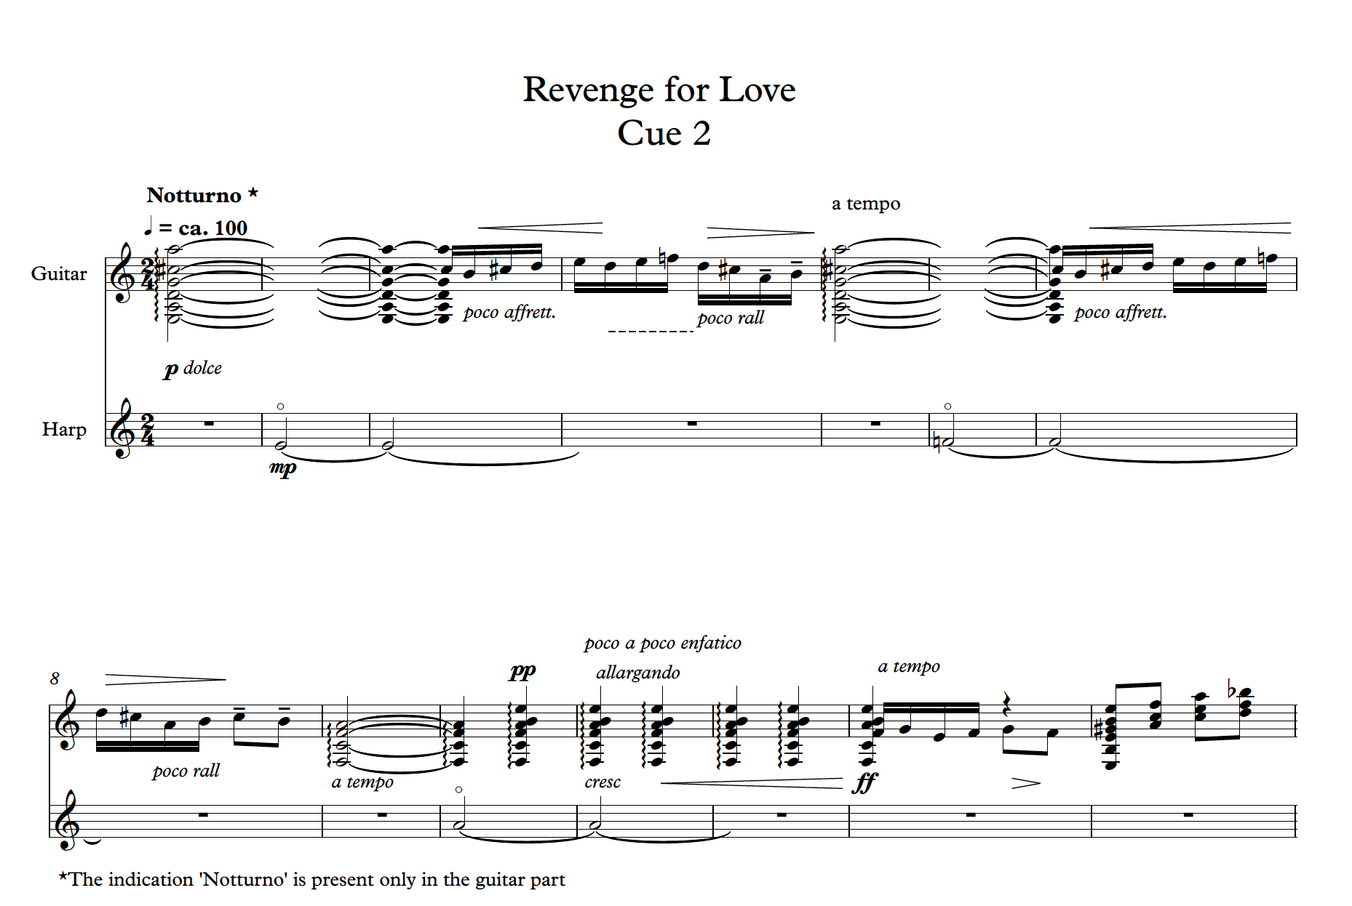*Figure 2 bars 1-15 Cue 2 Revenge for Love*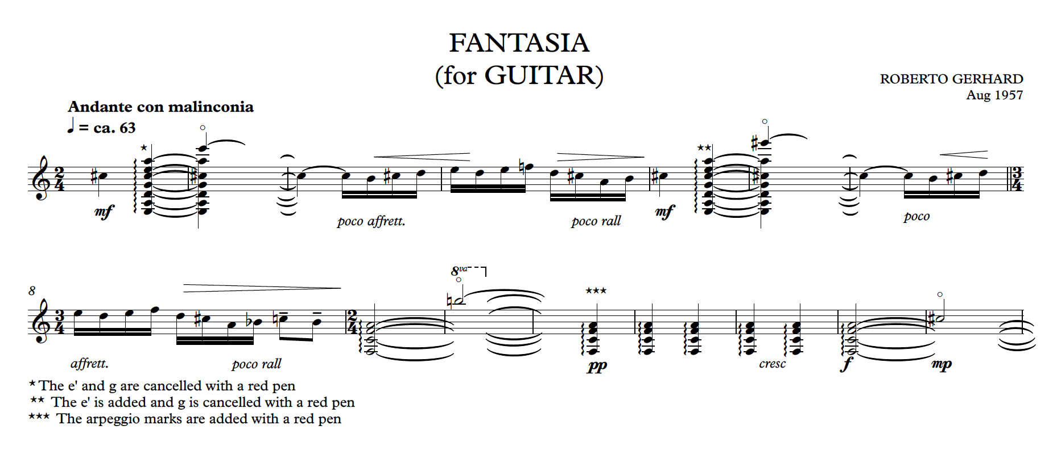Figure 3 bar 1-15 Manuscript Fantasia (Aug 1957)

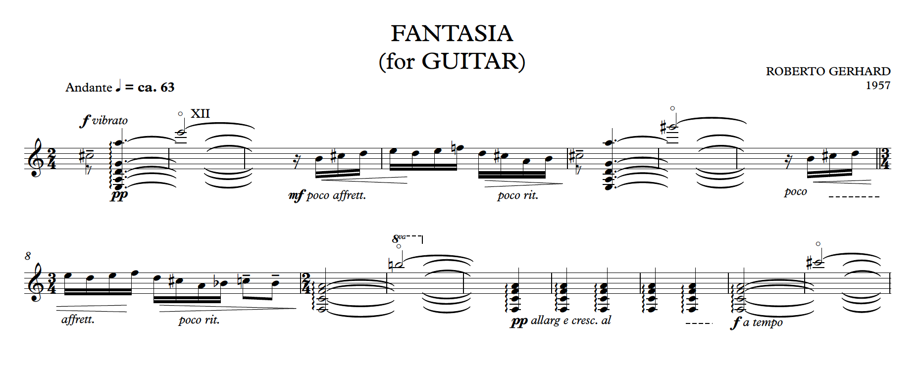Figure 4 bar 1-15 Published edition (Gerhard, 1964)

**Cap 1.4.2 For Whom the Bell Tools**

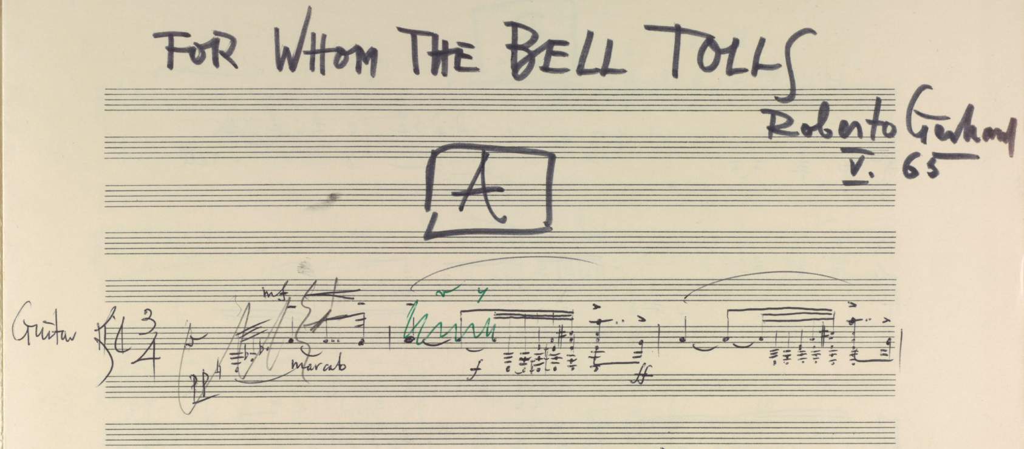*Figure 5 For whom the bell tolls - first page of the manuscript*

As mentioned before, Roberto Gerhard's *For Whom the Bell Tolls* was originally conceived as background music for a television program dedicated to Ernest Hemingway’s masterpiece. The book is set during the Spanish Civil War and tells the story of Robert Jordan, a young American that joins a republican guerrilla unit as a dynamiter with the mission of blowing up a bridge of central importance in the strategy against the Francoist army.

I found very fascinating how Gerhard chose a symbolic use of musical motifs to represent the plot of the book; this intellectual approach allows him to reflect upon the main themes of the book - love, war and death. To do so, he linked specific symbolic elements to elegant quotations from other works and recurrent motifs. In my interpretation, I decided to highlight both the importance of these references and the connection with Hemingway's book. Even if a listener may find difficult to grasp these aspects, they are an essential part of the music, and I believe that if we do not preserve them, the composition loses value.

Before starting creating my own version, I outlined a list of priorities that I wanted to follow:

* Use as much material as possible from Gerhard’s music with minimal intervention.
* Preserve and, if necessary, enhance the symbolic links between the book and the music.
* Create a structure that maintains the link with the plot of Hemingway’s book ~~but also allows the execution of the piece without a text.~~
* Try to maintain the BBC’s episode subdivision.
* Give a sense of unity and fluidity to the piece.

Of course, I also studied Hemingway’s book trying to understand which parts the composer and the director wanted to reproduce in the television version; without the scripts, I could only guess the topics of the episodes based on their titles. The titles of the episodes are not trivial as the director decided to underline some particular aspects of the story:

**I - Reconnaissance**: It refers to the first reconnaissance of the bridge followed by the meeting with the members of the Republican guerrilla unit (mainly Pablo, Pilar and Maria). After meeting the group, there is a second reconnaissance on the bridge.

**II - The moon of May:** It is not easy to identify a specific part of the plot just by reading the title. Actually, the *moon of May* is mentioned twice in the book. By analysing Gerhard's fragment in part II of the manuscript, I linked this title to a section of the book where there is a dialogue between soldiers bragging about their aviation.

**III - Verdict on Pablo:** This title refers to Pilar and Jordan’s decision to assassinate Pablo who has become dangerous and unstable. (This plan will actually fail.).

**IV - The bridge:** The last title is about the final mission, in which the bridge is exploded and the protagonist loses his life.

**The new version**

I divided the composition into four groups named after the four BBC episodes, which helpto follow the plot of the book. For the longest and most structured episodes, *I- Reconnaissance* and *III - Verdict on Pablo*, I decided to add subheadings to specific movements to create references that could explain my approach in revising the piece.

I - Reconnaissance: a) The bridge b) Pablo c) Pilar d) Reconnaissance

II - The moon of May

III - Verdict on Pablo: a) Un galán y su Morena b) The bell c) La muerte y la doncella

IV - The bridge

I also tried to connect the different fragments to create coherent movements, and I decided to minimise my modifications to the material written by Gerhard, partly because I wanted to respect as much as possible the work of the composer and partly because I realised that, just by connecting some fragments, I reached an artistically convincing expedient. In the next paragraphs, I will analyse the structure of the piece and my interpretation of the connections between the plot and the music.

The first episode is divided into four movements that narrate the first part of the book (the first reconnaissance of the *bridge* and the meeting with the members of the guerrilla unit, followed by a second reconnaissance). The motif associated with *the bridge* appears in the first and the last movement of the first episode, *a) The bridge* and *d) Reconnaissance*, and again at the end of the composition. However, each time I introduced some variations. Indeed, in the first movement, the motif ends on a suspended chord, while in *d) Reconnaissance* the theme develops into a virtuosic gesture and ends in *a* major chord. This difference reflects Jordan’s emotions: Jordan is full of doubts during his first visit to the bridge, while the music conveys his pride and positivity during the second reconnaissance with the members of the guerrilla, when he becomes certain of the success of the mission.

The two central episodes, *The moon of May* and *Verdict on Pablo*, are dedicated to the military aspect of the war and the duality of love and death, respectively.

In *The moon of May,* I combined three different fragments creating an ABA form, in which the A sections are whole fragments, while the B section is a combination of several fragments based on the same musical gesture. The rapid arpeggios of the A sections with their sudden dynamic changes symbolise the planes flying over; on the other hand, the B section has a more march-like style that, in a continuous crescendo, culminates in a rapid *rasgueado*, recalling the sound of a machine gun. The episode ends with some harmonics that were already used in the first episode.

I took two of the titles of the movements of the third episode, *Un galán y su Morena* and *La muerte y la doncella,* from two pieces of his *Cantares* (Gerhard, 1962), a series of songs for voice and guitar, because the compositions share the same melodies. In *Un galán y su Morena the melody is not original by the author but a* popular Catalan lullaby (Tobalina, 2006). I think that he decided to use this lullaby in *For whom the bell tolls*, to represents the love between Jordan and Maria. Jordan shows his love by trying to make Maria fall asleep and forget the horror of the war,

*b) The bell* (in which the sixth string is tuned in *d*) is the darkest and most intense moment of the whole composition. The gloomy atmosphere, the percussions, which stand for the sound of the bells, and the veiled references to *Homenaje pour "Le Tombeau de Claude Debussy"* by Manuel De Falla clearly link the piece to the theme of death. Indeed, this movement seems to foretell the death of Pablo, which is also suggested by the title of the episode. However, in the end, Pablo will be pardoned, and he will partially reconcile with his wife Pilar.

*La muerte y la doncella* conveys the troubled love between Pilar and Pablo, and Gerhard expresses the issues in their relationship by changing the original melody from the *Cantares* and making it fragmented and incomplete.

Finally, the last movement of the first episode portrays the explosion of the bridge and the death of the protagonist. The theme of the bridge reappears but it is gradually turned into a creep of grinding dissonance until the final explosion of the bridge, represented by three chords in ***ff***. Another important theme is the theme of death that is based on the melodic cell *e*-*f*, an echo of the *Homenaje pour "Le Tombeau de Claude Debussy"* by Manuel De Falla. It first appears in the ostinato of the third movement, *c) Pilar*,representing the part of the book in which Pilar reads Jordan's hand and foresees the death of the protagonist. The melodic cell *e*-*f* reappears at the end of the composition symbolising the death of the protagonist after the explosion of the bridge. The music, like the book, leaves the listener with a sense of disappointment for the death of the main character and the need to ponder the horrors of the war, always present, even in a successful mission.

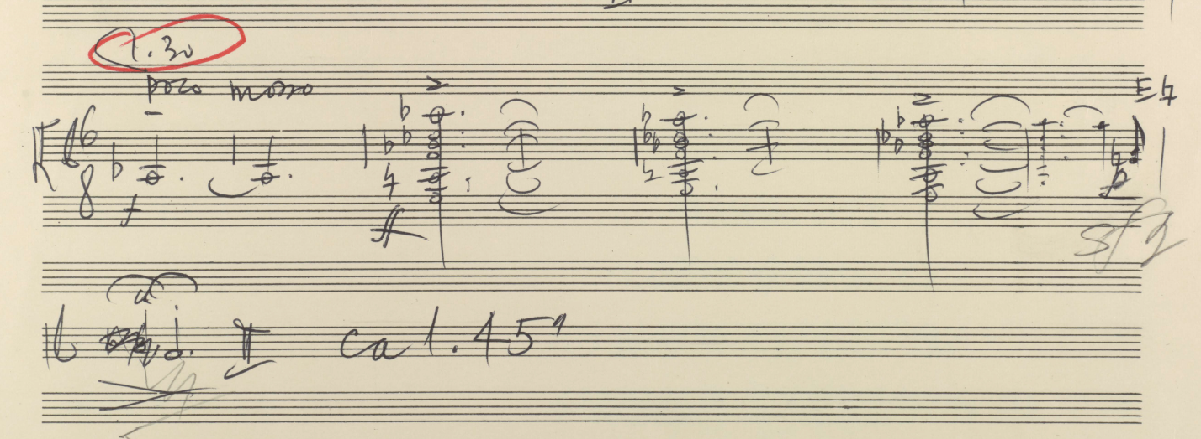Figure 6 *For whom the bell tolls – last section fragment JJ*

**Cap 1.5 Development project: the collaboration between guitarist and luthier**

In the Development project, I investigated, together with two great luthiers, the relationship between guitarist and guitar maker. Gabriele Lodi and Maurizio Foti give special attention to the relationship with the musicians and guitarists who visit their workshop, and they want to meet the needs of the twenty-first century guitarist by developing new resources of tone and colour, while maintaining distinctive characteristics of historical instruments.

The project was divided into four stages:

* Attend the Organology of Stringed Instruments Module (Edinburgh University)
* Test historical guitars owned by different collectors.
* Commission a guitar to Maurizio Foti. In this process, we discussed what kind of sound and type of instrument I was looking for.
* Organise, in collaboration with Gabriele Lodi, two events with concerts and lectures dedicated to deepening the understanding of some aspects of the guitar construction.

The collaboration with Maurizio Foti culminated in the realisation of an instrument that I used in many recordings of my doctorate. Besides following all the steps of the guitar construction, I exchanged opinions and discussed points of view with Maurizio, and, before every crucial phase of the construction, I spent days in Maurizio’s workshop to define the details of the guitar.. ~~This experience was very important to broaden my knowledge and it gave me the opportunity to understand and discuss Maurizio’s choices for the creation of the guitar.~~

The two events organised with Gabriele Lodi were dedicated to two important guitar makers, Hermann Hauser (1882-1952) and Francisco Simplicio (1874-1932), who were very interesting figures for my research because of two different reasons. Hermann Hauser represented an excellent example of a successful collaboration between a luthier and a guitarist. Indeed, because he developed his most successful model with the help of the Spanish virtuoso Andrés Segovia, and learning more about their collaboration is important to understand the evolution of the instrument in the first part of the twentieth century. Segovia was trying to widen the existing repertoire for guitar through collaborations with composers, and he needed a new instrument capable to support his ideas and express the new music written for him. Hermann Hauser was the luthier that helped him achieve the instrument he had in mind. The new model created by Hauser accomplished the difficult task of reaching the same quality of tone of the Spanish masters while increasing sensitively the sustain and the volume of the instrument.

On the other hand, I was interested in Francisco Simplicio because of his close relationship with the Catalan culture, which has been central in different projects of my doctorate [8]. Simplicio created many connections and collaborations with other artists from Barcellona and he can be considered as an exponent of the *Catalan art nouveau*. His aesthetic taste with rich of decorations, which can be seen as a mere display of his craving skills, needs to be look as a part of a broader artistic movement that involved Catalan painters, sculptors and architects.

Even the sound of his guitars, always evocative and expressive, seems to me as an attempt of the luthier to realise in sound the poetic of the Catalan composer of the first part of the twentieth century.

~~Studying his life helped me look into some aspects of the Catalan culture from a different point of view.~~

Cap 2 The Role of dedicatee

This chapter explores the different aspects of the role of the dedicatee and first performer of a composition, with a specific reference to the various collaborations realised in the doctorate.

The level of involvement of the dedicatee during the creative process towards the realisation of the composition, the typology of collaboration and background of the two artists, are important factors that can influence the role of the dedicatee significantly. The role of the dedicatee may not be confined solely to the performance of the piece: the dedicatee can also be an artistic collaborator involved in the compositional process.

I will explore the different aspects of the role of the dedicatee following a division based on the different phases of the collaboration between the performer-guitarist and the composer:

* *Before* the start of the composition
* *During* the process of composition
* When the piece is finished but requires *revision*
* When a composition has reached its *final* *stage*

Apparently, the dedicatee can be involved in some or all the phases of the creative process.

**Cap 2.1 Before the start of the composition**

The inception of the collaboration can take place before the genesis of the work, when the composer and performer are familiar with or get to know each other’s opinions and ideas and discuss some aspects of the future work.

In what follows, I will explore two different approaches to the role of the guitarist in this early stage of the collaboration: the first one is dedicated to the particular case of the collaboration with non-guitarist composers, while the second explores the role of the dedicatee in a broader context.

**2.1.1 The dedicatee as a medium between the composer and the guitar**

In the case of composers who have no previous experience in writing for the guitar, the role of the dedicatee, during this phase, may not be confined to giving the composer stimuli or suggestions: the dedicatee may also act as a *medium* between the composer and the instrument. In this phase he may guide the composer in her/his first approach to the instrument showing its potentials and limitations and helping him/her to discover its repertoire.

Based on my experience of collaboration with non-guitarist composer, I identified a subdivision of this stage of the collaboration in four distinct phases (not necessarily consecutive):

* **Playing for the composer:**   
  The performer plays selected compositions with the aim of showing the sound and the different potentials of the instrument.
* **Showing the repertoire:**   
  The dedicatee helps the composer to explore existing repertoire for the instrument.
* **Advice for writing for the instrument:**   
  The dedicatee gives some advice, instructions and restrictions that can help writing idiomatically for the guitar.
* **Encouraging creativity:**   
  The guitarist helps the composer to find a compositional approach, by means of which, within the idiomatic writing restrictions, he or she can freely express his/her creativity.

In the case of my collaboration with Raffaele De Giacometti the first step of the cooperation commenced in an early meeting in which I played some compositions and explained certain guitar techniques. The composers asked me to try some melodic elements and particular techniques with the curiosity to explore specific sonorities. These first meetings, initially instructively designed, have been transformed by the curiosity of Raffaele in interactive moments were both composer and performer explored together the potential of the instrument.

At the end of the meetings I gave the composer selected scores and recordings of exemplary guitar compositions written by non-guitarist composers. I tried to form a heterogeneous set, selecting three pieces written in a more traditional language and five including unconventional techniques, aiming also to show the potential of the instrument to feature various compositional qualities: homophonic, polyphonic, contrapuntal, rhythmic, percussive, and harmonic.

|  |
| --- |
| Traditional languages:   * Toru Takemitsu (1930-1996): In the Woods: 3 Pieces for Guitar * Benjamin Britten (1913-1976): *Nocturnal After John Dowland*, op. 70 * Federico Mompou (1893-1987): *Suite Compostelana*   Unconventional languages:   * Helmut Lachenmann (b. 1935): *Salut für Caudwell* * Julian Anderson (b. 1967): *Catalan peasant with guitar* * Luciano Berio (1926-2003): *Sequenza XI for guitar* * Hans Werner Henze (1926 – 2012): *Royal Winter Music. First Sonata* * Alberto Ginastera (1916-1983): *Sonata for guitar*, op.47 |

The idea to familiarise the composer with the guitar by pointing at selected compositions had been also adopted by Andrés Segovia in many of his collaborations, as the Italian composer Mario Castelnuovo-Tedesco notes:

*"One day in 1932, my wife Clara, being in Venice, found herself travelling on the same ferry as the great Andrés Segovia. The Maestro spoke to her about his wish that I would compose for the guitar. I wrote expressing my desire to write something for him, neither knowing the instrument nor how to compose for it. In return, Segovia sent me two pieces which demonstrated the guitar's capabilities: Sor’s Variations on a Theme of Mozart, op. 9, and Ponce’s Variations on Folia de España and Fugue.” (Otero, 1999 p.48)*

The next two phases are to a certain extent in opposition and therefore need to be cleverly balanced: offering the composers tools to assist them in writing idiomatically for the guitar and also leaving them the freedom to explore the instrument in a personal and unique way.

During my collaborations I prioritised in encouraging the composers to feel the freedom to explore the guitar without too many limits: the indications I gave were limited to showing the range of the instrument and some polyphonic and technical constraints. I mainly encouraged them to think out of the box and to push the boundaries of the instrument. This approach was also important in intensifying the collaboration in the following phases of the creative process.

In addition to the dedicatee’s advice, a relevant number of resources related to the idiomatic writing of the guitar have been recently made available, giving useful tools to non-guitarist composers(Bonaguri, 2015)(Godfrey, 2013)(Josel and Tsao, 2014). Nonetheless, many composers prefer a direct approach with the instrument: Thomas Wilson[9] and Julian Anderson (Anderson and Zanon, 2017) have tried to actually play the guitar. While this approach can help the composer to acquire a deeper understanding of the practicalities of the instrument, on the other hand it requires a long-time engagement and cannot guarantee an exhaustive overview of the technical and expressive potential of the guitar.

It should be noted that a considerable part of the twentieth century guitar repertoire was written even without a basic knowledge of the instrument and through collaboration with the guitarist. Two excellent examples are the composer Mario Castelnuovo-Tedesco, who wrote in a letter to Mario Gangi (1923 –2010) that he was not even able to play the open strings of the guitar (Carfagna and Del Greco, 2016, p.22), and Terry Riley who collaborated with the American guitarist David Tanenbaum:

*“I wrote Ascension at the piano knowing that I would be able to collaborate with you. That was an important decision. Because you were able to provide technical knowledge on the guitar, I was able to work solely on musical ideas. Unless a composer is all-knowing and all-seeing, it's a great way to work: you can pool knowledge.”* (Riley, quoted in Tanenbaum, 1995, p. 11)

**2.2.2 Give the composer stimuli for the creation of the piece**

When two artists start collaborating, their background, previous projects and ambitions can be conveyed into the relationship. The conversations, meetings and exchange of their artistic activities therefore become the instruments of mutual knowledge that fuel the successive steps of the collaboration.

My collaboration with the composer Kai Nieminen and with the performers Andrea De Vitis and McNeill Savaloni Duo started before the compositional process.

Before the beginning of the long compositional process of *Shades…Fantasia-Sonata,* Kai and me deepened our mutual knowledge through weekly Skype calls. This period of musical conversation, represented a significant step for our collaboration. Initially, our conversations were not aimed at a concrete goal but moved by a need to discuss and share our respective musical ideas. Following this phase, there was the inception of the collaboration for the creation of a new ambitious piece, an idea matured on both sides, and a discussion of some ideas has begun to take place.

During this phase, the character of the piece and the specific tuning (Eb Ab d g bb e’) started to be exanimated and discussed. This period was a moment of mutual influence where Kai Nieminen asked me to be involved as a dedicatee and give him ideas connected to my personal approach to the instrument.

Similarly, in the case of *Dida's reminiscence*, commissioned by the Paganini Festival in Parma, and of *Moon*, written for a concert at the St Magnus Festival, the first discussions about the pieces took place well before the compositional process.

The two pieces were commissioned for a specific occasion and the dedicatees gave some restrictions and specifications connected to their specific needs as performers and the situation in which they have to play.

These constraints became also a source of inspiration offering elements that could be explored. Sasha and Andrea were excellent advisors. They also played an important role in encouraging and motivating me.

As a composer, I consider the compositional act as a moment in which, through the music, I establish a personal communication with the artist to whom I am writing for. In all the pieces I composed in this doctorate, the first step was to listen and talk with the musicians. Alongside with understanding their requests I wanted, even more, to get an idea of their musical vision, personality, technique and musical approach. Being a performer myself, this process is also moved by the curiosity of discovering visions different from mine. In these cases, the dedicatee also plays a passive role, being an inspiration for the composer.

**Cap 2.3 During the compositional process**

During the compositional process the role of the dedicatee can vary depending mainly on the level of involvement the composer requires.

In the case of composers who prefer to consider the act of composing as an intimate and solitary process, the role of the dedicatee is obviously marginal and basically limited to supporting the composers in specific cases, for example where they doubt on the feasibility of some passages or need to further negotiate the limitations decided on an earlier stage.

In other circumstances, the composer may need a more interactive relationship with the guitarist, sending notes and drafts and asking for feedback.

In addition to the feasibility check of some passages, the composer may request a greater involvement by inviting the musician to suggest more idiomatic solutions of the material being sent or by asking the dedicatee to improvise on specific materials in order to explore idiomatic compositional possibilities.

I was involved in this type of collaboration with the composers Yip Kimfung and Kai Nieminen and the musicians Sasha Savaloni and Leonardo De Marchi. In these collaborations, the dedicatee was fully involved in a frequent interaction, testing new material sent by the composer or exploring techniques or passages involving unconventional techniques. As a result of these processes, the contribution of the dedicatees had a *substantial* impact on the piece.

A very similar procedure was followed by Laura Snowden in collaboration with the composer Julian Anderson for the piece *Catalan peasant with guitar*.

*“Julian Anderson and I met regularly throughout the process, which is how he prefers to work,” Snowden says. “He might bring a particular series of notes, which he’d ask me to play in different ways or even improvise around. I was really struck by his acute ear for timbre, and his ability to produce truly inventive and authentic ideas while considering the practicalities of the guitar. “* (Snowden, quoted in Wassily, 2016)

In all these compositions, despite the significant help and participation of the dedicatee in the compositional process, the responsibility for the content of the score was entirely in charge of the composer. This sense of responsibility for the artistic content of the piece identifies the composer as the only author of the piece[10].

On the opposite, there may be cases when this responsibility and consequently the authorship of the composition is shared between two or more people.

**Cap 2.4 When the composition is finished but requires revision**

When the piece has reached a sense of completeness in the mind of the composer – especially when the compositional process was not thought on the guitar – it begins, in most of the cases, an intense collaboration with the guitarist for the realisation of the revision.

This phase varies a lot according to the piece and can be incredibly delicate and challenging for the dedicatee who needs to balance the intention expressed by the notation, the way of approaching practical problems in the realisation of the music on the instrument, her/his techniques and expressive sensitivity and the context of use of the piece.

This negotiation phase will be explored in the chapter below entitled *Revision as Negotiation.*

In the process of adaptation of the text in order to optimise its effective realisation on the instrument, the fingering also plays a role of great significance as it makes an interpretation of the text, as Richard R. Knepp notes in his work on the Andrés Segovia - Manuel Maria Ponce collaboration:

*“The research illustrates that, more than re-voicing chords, more than altering placement of dynamics within a score, more than adding colorful programmatic titles, Segovia’s true collaborative influence is found within his unique approach to fingering music on the guitar.”* (Knepp, 2011)

Sometimes, pieces that have reached this moment of revision come back to the composer who may rethink and rewrite certain passages or the entire composition. The motivations are varying and several: the composer may decide to rethink a part of the piece after listening to the realization on the instrument or understanding the difficulties in the realization. The composer may also correspond to a request from the guitarist who is not finding effective solutions during the negotiation/revision process of the piece.

Another reason was found during my collaboration with the composer Marco De Biasi in *Vento d'Inverno*. Marco De Biasi, a sensitive and gifted composer, is also a virtuoso of the instrument. It is not surprising that *Vento d'Inverno* showed an excellent idiomaticity since its first draft. The process of fingering was an occasion to compare our own techniques and led to the delineation of marginal, I would say, changes.

The composition was performed at the July 10, 2016 at the National Gallery in Edinburgh. In spite of the warm appreciation by the audience, I felt that the piece sounded as if it was not really concluded. This feeling was also shared by Marco De Biasi. After the first performance, I suggested that Marco should add a final coda in order to attribute a more conclusive ending to the piece. After a few weeks, Marco sent me a new version with a coda that changed the balance and the structure of the composition. The piece obtained a greater sense of completeness and we proceeded to the publication and the recording.

**Cap 2.5 When a composition has reached the final stage**

Working together on the interpretation of the piece for its first performance can be a very exciting time for both the composer and the interpreter because of the nature of the interpretation and its deep connection with the profound meaning behind the work.

These two extremes, the genesis of the work and the final moment of the execution, its presentation to the public, find a synthesis in the interpretation phase. Particularly, it is very interesting when both the creator and the performer participate in the definition of the interpretation.

From the point of view of the interpreter, my meetings with the composers before the first performance were incredibly helpful and extremely influential in the final result. I went beyond the score and the indications and together with the composers I tried to understand the deepest meaning of their works, trying to observe the score from their point of view through which I was able to form mine.

Experiencing this moment as a composer, led to a rediscovery of the piece under a new light. The only piece I have composed before the course of my research is *Im Nebel*, a composition that I also performed. During the course of my research, however, I worked again on the composition with Sean Shibe, the dedicatee of the piece.

We met several times to discuss the composition and explore some new ideas; each meeting was a discovery.

The execution of Sean diverges from some of my indications made at the time of publication: at first sight his interpretation seemed to diverge from my compositional vision. However, the resulting poetic and tension effect is what I was really looking for. In a sense, I felt that differentiation from some of my choices was more respectful.

The musical text is an intermediary of something deeper, revealed in unique ways through the process of interpretation. A performer can diverge from the notation while keeping a high degree of fidelity to this deeper meaning; Richard Rodney Bennet (1936-2012) quotes:

*'Julian [Bream] does some things in the guitar Concerto that are not in the score,' he said. For example, he does a rasqueado that I didn't write. But he likes the idea of playing it his way and he was determined to do it... Julian's performance may be eccentric, but it has depth and poetry. John Williams played the Concerto extraordinarily, with no difficulty at all. He is a marvellous player but — I even hesitate to say this — John's performance didn't have the poetry of Julian's.'* (Bennett, quoted in Tosone, 1996, p. 12).

Cap 3. Revision as Negotiation

When a composer is not a guitarist or familiar with the guitar, guitar music is often composed without carefully considering the many limitations, but also the strengths of the instrument. This can also be the case when composers, who are indeed expert guitarists, prefer not to have their creativity constrained by practical technicalities during the compositional process. In both cases, the process of *revision* is crucial in order to adapt the composition to the instrument and an important component of the collaboration between composer and guitarist.

This chapter is dedicated to the exploration of the main elements of this key phase of musical creation. In doing so, I draw inspiration from the approach adopted by the Italian writer and linguist Umberto Eco in the book “Dire quasi la stessa cosa” (Eco, 2013) in the context of the translation of a text.

According to Eco, the act of translation firstly requires a process of interpretation of the different levels of meaning of the text: it should shed light not only on its textual content, but also on the cultural context and the *possible world* (using Eco’s own words) that the text represents.

The role of the translator is to *preserve* as much as possible all these different levels of meaning, with the aim of creating a *functional equivalence* with the translated text. As described by Eco:

“Instead of speaking of equivalence of meaning, we can speak of functional equivalence: a good translation must generate the same effect aimed at by the original. Obviously this means that translators have to make an interpretative hypothesis about the effect programmed by the original text, or, to use a concept I like, to remain faithful to the intention of the text. Many hypotheses can be made about the intention of a text, so that the decision about what a translation should reproduce becomes negotiable.” (Eco, 2004, p. 56)

Reflecting on the process of revision, it is worth clarifying that the intention here is not to draw a parallel between the work of a *translator* and the work of a *guitarist-revisor*: these are undoubtedly two different professions, with different objectives and working methods. Nonetheless, adapting some of the concepts by Eco as suggestions to explore the process of revision, will hopefully offer new perspectives.

In the next section I work around the concept of *negotiation* to define and present in detail three main stages of the revision process. In the session 3.1.4, I will show how the ideas of *losses* and *compensation* introduced by Eco can also be used during this process.

**Cap 3.1 The concept of negotiation**

To investigate the main elements/phases of the revision, it is worth starting from recognising that it is not a purely objective activity. On the opposite, it always requires to take a stance and make choices among many different possibilities. The various options derive from the variety of interpretation that the same score can suggest and to the fact that the same music can be realised on guitar in several ways.

It is clear that this type of choices always implies a certain degree of subjectivity from the revisor, which inevitably determines a margin of *infidelity* from the original text. Despite the negative connotation that this word may provoke, it is often an opportune necessity as I will comment on. Nonetheless, if not accurately motivated, *infidelity* can distort the deep intention of the music.

It is for this reason that the revisor plays a crucial role in preserving the intention of the author and the artistic spirit of the composition, i.e., in reaching a functional equivalence between the original source and the revised version.

In this sense, the concept of *negotiation* is a key element in the revision process. It signifies the sets of compromises and decisions that the revisor must take to balance the *trade-off* between the fidelity to the original text and the practical problems in realising it on the instrument.

This process can also be supported by the author herself/himself, if possible. In this case, all the revisions/negotiations can have an approval directly from the composer, hence significantly relieving the revisor from the burden of choice.

In order to better understand the concept of negotiation, it is useful to divide the process of revision in three different phases:

1. Interpretation of the source text
2. Identification of problems in the realisation on the instrument
3. Compromise between different elements

**3.1.1 Interpretation of the source text**

When revising a score, a stage of interpretation is necessary.

Why this phase of interpretation is so essential? If the vision of the interpreter is based on the supposition that -- as explained by Eco in the case of the translation -- the aim of the revision is to try to remain faithful to the *intention of the text*[11], the interpretation is the indispensable phase where the revisor makes a hypothesis of what this intention could be.

In this section, we do not want to tackle the difficult task of providing a definition of interpretation in music -- perhaps a book would not suffice -- but we would try to develop some helpful concepts to interpret the text for the purpose of a revision. In this stage, we do not want to suggest that the interpreter has to define and understand in an absolute way the intention of the score - something that we think really difficult and even pretentious - but to formulate a hypothesis of which aspects of the composition are essential and define it.

In what follows, we will look on what we have to consider to interpret a score, and then a possible way to proceed to describe the interpretation.

It is necessary to recall again the crucial need for the revisor to look beyond the textual and graphical content of the music and try to interpret the musical intention expressed by the text. To do so, three are the main sources from which a revisor can obtain information:

The first one is the text itself: all the components present in the score are meant to provide a set of information to the performer in order to realise the musical effect.

The second source is external to the text and is expressed by the *cultural context* in which the piece was composed. To interpret a composition is not enough to focus on the notation but it is also required a contextualization in time, space and even in personality. We cannot consider the musical text as something autonomous and independent from the composer who creates it and the cultural world in which it was generated.

The third source is the composer who can provide explanations and interpretations of the piece through collaboration.

Using Eco’s word, *a text is the manifestation of a substance* (Eco, 2004, p.28). In the case of a musical text, the substance is a really complex organism. For the purpose of analysing this complexity, it is important to introduce the concept of *levels of substance* that can help us to observe and describe this substance.

While researching the internal and external sources, it is possible to look at the music-text from different *levels of substanc*e that focus on certain aspects of the music. These levels vary significantly on the base of the context and the musical language of the composition; therefore, an important step in the interpretation process is to find the more suitable substantial level to observe the score.

To further clarify this concept, it would be helpful considering the following example. If we had to analyse a nineteenth-century Sonata by a German-composer, conceivably the most interesting levels of substance would be the harmonic level, the melodic level, the formal level, and the dynamic level. Obviously, our approach would be quite different if the composition under analysis had been written in the first half of the twentieth-century with a twelve-tone technique. In this case, to describe the notation content of the music we would need to look at different levels of substance, for instance levels related to the specific twelve-tone technique used by the composer.

After observing the text from the different perspective of the substantial levels, it is also essential to link and correlate the observation interpreted in the different substantial levels. In fact, as we observed through my practical experience, it is linking and searching into the deep-connection between levels that enabled me to discover the *non-negotiable aspects* of the piece. Those aspects are that one that we consider necessary to preserve during the revision to express our interpretation of *deep intention* of the text.

To summarise, the substance levels could be simply defined as means to observe and describe the music. By analysing and linking different levels of substance, the revisor can identify and decide what she/he thinks the revision process should ideally preserve.

**3.1.2 Identification of problems in the realization on the instrument**

As noted in the introduction, the guitar is a surprisingly complex instrument, with its own peculiar set of weaknesses and potentialities. For this reason, a second important step of the revision process is to recognize the difficulties in executing the *intention of text* (as interpreted in the first step discussed above) on the guitar.

It should be stressed that the role of the revisor in this stage is not merely confined to a “test of feasibility” on the instrument of the written content. Indeed, the revisor has the much more delicate responsibility to identify the obstacle to achieve the intention in its particular *context of use.* For context of use, we mean the specific objective/goal of the revision, that can add additional constraints to the revisor.

For instance, if the revision is meant to create a publication for educational purposes, the revisor will be expected to adapt the original composition taking in consideration the technical and musical levels of the addressed students. If the same composition would have to be revised for a *première* at the Wigmore Hall in London, the revisor will be expected to adopt a radically different approach.

**3.1.3 Negotiation**

After the interpretation phase and the identification of the difficulties on the instrument, it is time for the revisor to negotiate possible solutions. What should the revisor take into account in elaborating proposals and eventually taking decisions? The most important elements to be carefully evaluated and weighted are:

1. The interpreted intentions of the text (analysed on several levels of substance);
2. The technical and expressive potential of the instrument;
3. The *context of use* of the revised piece;
4. Other negotiations during the revision.

The elements 1) to 3) have been already discussed in the context of the first two phases of the revision process. Let me focus here just on the other negotiations during the revision: Any decisions made during the revision process can have impacts on previous and future decisions to be made in other passages that are somehow connected. I will refer to this type of impact as the *ripple effect* of a negotiation. Considering the ripple effect when taking a decision is crucial to ensure the coherence of the final outcome of the revision, as well as to make the revision process more efficient.

We also have to mention another aspect that, although not presented as element to be considered in this stage, has a relevant impact on the revision: the artistic sensitivity of the revisor. It is widely recognized that the revisions by renowned virtuosi like Andrés Segovia and Julian Bream are strongly influenced by their poetics and musical tastes. Is it common that negotiates are so influenced by the revisor’s sensitivity? I personally think that it is; indeed, to a certain degree, it is always the case. Even if a musician decides that he absolutely wants to avoid any involvement of his artistic sensitivity in the final text, he is already influencing the negotiation through his personal opinion concerning the revisor process.

To conclude, I think it is worth going back to Umberto Eco and his final suggestion for a *faithful* translation:

* interpret with passionate complicity
* Engagement in isolating what is for us the deep sense of a text
* The goodwill that prods us to negotiate the best solution for every line.

Similarly, we think that also in the case of the revisor these three behaviours combined with the ability to define the problems and to find solutions could become an honest way to approach the source text, in the respect of the composer and of who will study the text.

**3.1.4 Losses and compensations**

In the previous section we explored the dynamics of “revision as negotiation” through three different phases. In this one, we propose an adaptation of the concepts of *losses* and *compensations* introduced by Eco, in order to apply them to revision. As we will discuss, this adaptation can be particularly useful for the revisor to better understand the impact of his work of revision on the original text.

As already said, the revision/negotiation always inevitably involves a margin of infidelity. First of all, this is due to the fact that the revision is based on an interpretation of the original text that is never, by definition, fully objective. In addition, sometimes the nature of the guitar simply does not allow to reproduce exactly the same intention of the original text. The resulting infidelity can be examined in terms of losses and compensation.

The concept of *losses* refers to the parts of the *layers of substance* interpreted that are not preserved by the revision. There are obviously different degrees of *losses.* Losses that do not affect the deep intentions of the text (as interpreted by the revisor) can be accepted by the revisor as a natural part of the revision process. On the contrary, the case of losses that distort the interpreted intentions of the score can give rise to ethical and artistic concerns.

In this case, it is strongly advisable for the revisor to include in the final text of the revision the proposed modification alongside the origin text, giving the opportunity to the performer to go back to the original version.[12]

The concept of *compensation* refers to an addition by the revisor aimed at preserving the *functional equivalence* of the original text. With a compensation, the revisor is making an addition to counterweight a loss and retain the interpreted intention of the original text. In this sense, a compensation is a small lie to keep faith to the deep intention of the composition (as interpreted by the revisor). This is a crucial distinction from the so-called artistic re-writing or any other artistic licenses.

Within collaborations between the revisor and the composer, the losses and the compensations can be made by agreement of the parties (Eco, 2004). It goes without saying that, in this specific case, even absolute/major losses could be considered acceptable and “authentic” if they are directly approved by the author.

**Cap 3.2 A case study: In Absentia Essentia**

In this section, I will apply the concepts developed and discussed above to illustrate a practical work of revision that I personally carried out between September and November 2015 on the piece *In absentia essentia* by Raffaele De Giacometti.

The revision here presented is part of a broader collaboration started in September 2015 between Raffaele and myself. At that time, we had both just started our studies at the Royal Conservatoire of Scotland. We soon perceived a mutual desire to work together, and *In Absentia Essentia* represented an opportunity to establish a fruitful collaboration and to strengthen our friendship.

*In absentia essentia* -- which was titled *Saudade* in its first version -- is a piece not originally conceived for guitar. It is an elaboration of a transcription of an improvisation made on the piano. Raffaele, as he wrote in the program note for the first performance of the piece[13], later decided to use this improvisation to compose a guitar piece: *“After meeting Marco Ramelli, to whom the piece is dedicated, I thought that the ideal instrument to express my ideas would be the classical guitar, not only for the intimate timbre required by my piece (as suggested by the title itself), but also for the nostalgic character that such an instrument is magnificently able to express.”*

I first received a version of the piece from Raffaele in September 2015. As is often the case with pieces originally composed on a different instrument, a process of revision was required to make it possible on the guitar. In fact, while the poetic idea and the polyphonic density were apparently compatible with the guitar, some technical obstacles needed to be resolved. What follows briefly presents the three phases of this revision, and how Raffaele and I arrived at the final outcome.

**3.2.1 Interpretation: Discovering the music**

The first phase of the revision started with the interpretation of the piece. As observed in Section 3.2, the main aim of this phase is to grasp the different substantial levels that can efficiently describe the interpretation of what is the *deep intention* of the music under review.

From all *substantial levels* to be potentially analysed, I chose the four that seemed to me particularly appropriate to explore the music by Raffaele: 1) the Poetical level, 2) the Musical content level, 3) the Structural level, and 4) the Sonority level.

I will now briefly summarise my own interpretation of each of these four levels. As it will soon become evident, the Poetical and Sonority levels refer to the expressive ideas of the composition, while the Musical content and the Structural levels refer on the more purely musical components. However, each one of these levels is not fully self-contained, but it is inter-connected with the others. Hence, there are cases of interpretations that I attributed to one level that are also connected to the other levels. For conciseness, I have intentionally avoided to repeat the same concepts twice.

1) Poetical level

*'In Absentia Essentia'* is a composition that explores the emotional world of melancholy with delicate and ethereal atmospheres. The incessant repetition of the obstinate is contrasted by melodic leaps that describe different emotional states: miss, sadness, acceptance, serenity.

I first deducted the general poetic idea of the piece through the observation of the music score. From the sheet music, already the title of the first version of the composition -- as already said, *Saudade* -- provided a first clue of the poetic atmosphere of the piece. In fact, as widely known, *Saudade* is that particular feeling of melancholy and nostalgia that is considered common among the Brazilian people. However, while its mood is indeed melancholic, the piece does not have any explicit link to the Brazilian music or culture. Also for this reason, later on during the process of revision, Raffaele decided to remove any reference to the Brazilian culture, changing the title to *In Absentia Essentia*.[14]

In a second instance, I refined my interpretation of the piece with several daily discussions with Raffaele throughout the process of revision. Thanks to the collaboration I was able to discover more of the *context* from which the piece was composed.

*In absentia essentia* generated by an improvisation inspired by a deep state of melancholy. Some elements of extemporaneous genesis are still recognizable in the final composition. As described by the author, the improvisation was performed *at his home in Italy* a few months before. During the performance, Raffaele was sitting off-center on the right side of the instrument, as in the four-handed piano composition performance, and he used the resonance pedal with the left foot.

This particular position besides helping the composer to reach the higher register of the instrument, had above all a symbolic meaning: the idea of playing with the absence of someone. Further, the unusual sit clearly affected the use of the registers, for example: in the whole composition the lower notes are used in only two isolated passages.

2) Musical content level

Already from a first look at the piece, it is easy to visually recognise the main elements of the composition. The piece is notated in two staffes, clearly separating the two main elements. In the lower staff, we have an obstinate of two bars that continues unaltered throughout the composition, while in the other melodic phrases of different lengths follow one another.

In my interpretation -- obviously also on the poetic level -- the obstinate is a metaphor of an element of nature that as humans we cannot alter -- as for example, the flow of time --. On the contrary, the melodic line with his sinuosity and variety ideally represents the human feelings, in particular the different states of nostalgia.

With the proposed interpretation, it was clear to me that, if necessary, it was allowed (during the revision process) to make small changes in the melodic line, as they are mainly expressions of an improvisatory language. But on the contrary, this interpretation posed also an important constraint: the necessity to preserve the immutability of the ostinato.

Guided by this observation, I tried to understand the melodic mode and scales used by Raffaele. Instead of a written analysis approach, I used the *improvisation* as research tool. I improvised starting from the melodic elements written by Raffaele and then diverging from the original text while preserving the same modal and expressive context. In this way, I was trying to recreate the same condition of the origin of the composition.

It is important to clarify that my improvisations are not incorporated in the final revision. However, this process was an extremely helpful tool to explore and absorb the musical language used in the composition. This improvisatory approach became the main element of another electro acoustic composition by Raffaele De Giacometti: *Ramelliana*.

3) Structural level:

On a structural level, the piece shows a great sense of unity. The overall dramaturgical charge is well calibrated, with different sections each one with internal climaxes.

Raffaele designed the macro-structure of the piece based on calculation of golden ratio. During the conversations with the author, it was clear that the form was for him an *essential* element to communicate the intention of the piece. Consequently, the overall structure of the composition and the modulations were two *non-negotiable* elements.

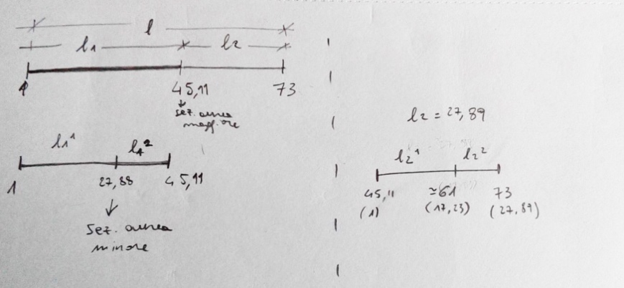

Figure 7 Manuscript of Raffaele De Giacometti with a graphic representation of the structure of *In Absentia Essentia* in relation of the golden ratio.

4) Sonority level:

For Raffaele the sonority of the piece is one of the crucial aspects of the composition and necessary for express his intention. In our meetings, Raffaele helped me to enter in the sound world that he wanted to create.

Resonance is the most important element of this *sound world*. Each note of the ostinato need to be letting vibrate during the piece, to create a sonority rich of resonance. In doing so, Raffaele wants to facilitate the creation of a meditative and intimate atmosphere that can brought the listener to a particular state of mind.

On the contrary, in some of the melodic passages -- in particular those that go on the higher register -- he required a dry, percussive sound. Not an aggressive sound, but bright and tense in order to express the suffering feelings related with nostalgia.

*In Absentia Essentia* is also a piece requiring an extremely wide dynamic range: from ***pppp***to ***ffff*** . In particular, in the climax passages it is required a fast and dramatic crescendo, that forces the limit of the instrument. In this point, Raffaele wanted a rough, less refined loud sound able to show the dynamic limits of the instrument,

Obviously, this reflections about sound are also connected to the poetic level, sound is the way as we convey the musical expression. If we say “be calm” with a nervous and unpleasant voice will not transmit the effect mean by the word to the interlocutor, and the same is with music.

**3.2.2 Discovering the obstacle**

The main obstacle to the realisation of the composition on the guitar was the impossibility to play the ostinato and the melody at the same time, as written by Raffaele, in all the passages of the composition.

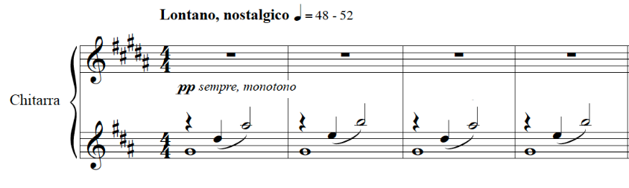

Figure 8 – First four bars of *In Absentia Essentia* before the revision process.

The notes that composed the obstinate are mainly *fretted note* - with the exception of the *e’* - which means that to produce the notes we need to use both hands. In addiction, the obstinate is in two voices in which the lower one needs to be sustained for the entire bar. These facts pose serious restrictions in the realisation of the melodic line as we are already using too many fingers.

The independence between ostinato and melody is certainly a core element for the realisation of the intention of the piece. On the piano, it is possible to play the ostinato with one hand and the melody with the other, but, on the contrary, on the guitar this is not possible: we have to produce both ostinato and melody involving the same two hands.

It was clear that during the revision process was needed a solution able to resolve not only some local problems, but that enable to always create this independency.

Obviously, several more obstacles were just behind the corner, but I knew from the beginning of the revision that this one was the crucial one. Without solving this problem we needed to resign to the impossibility of playing the composition on the guitar.

**3.2.3 Negotiation**

The moment of negotiation is the phase when the revisor provide potential solutions to the problem. Once a proposal is defined, I tried to understand the losses and the compensations necessary, and in a second time I proposed a solution to be submitted for the approval of Raffaele. Many proposal were rejected by me because they altered too much my interpretation of the text. Similarly, others were rejected by Raffaele.

We wanted not only a solution that could allow to play with ease both the ostinato and the melody, but also something able to preserve the poetic, the sonority levels and that was as much as possible faithful to the material written by Raffaele. All of above without changing the structure of the piece and the constant presence of ostinato that were two non-negotiable elements.

The fact that the ostinato was a non-negotiable aspect and that it was also the reason of the problem in the realisation on the guitar, offered me a starting point for my research. Raffaele was not inclined to modify the ostinato, so it was the guitar that somehow needed to be adapted to the ostinato. I tried different tunings to be able to play the ostinato with more open strings.

The revised text is an expression of our solution to the main problem. We have to say that it was not the only possible, but the one that for us is the best negotiation between the interpreted intention of the text and the possibilities of the instrument. Other solutions, even if they allow the realisation of the notes on the guitar, did not allow an execution that respects the character and sonority interpreted.

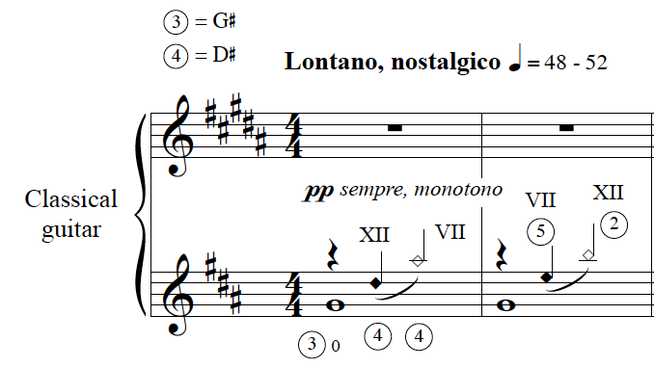

Figure 9 - First two bars of *In Absentia Essentia* after the revision process.

Our solution was to tune the guitar with the third and fourth strings a semitone up (E A d# g# b e’). This new tuning allows to play the ostinato with a combination of open strings and natural harmonics, in both cases note playable involving only the right hand.

With this tuning, it was possible to play the melody and to create the necessary independence. This solution is a compromise, it preserves more of the text and our interpretation, but new tuning raised the level of technique required and made the piece a real challenge for the performer. In a few bars, we needed to give some concessions also to easiness of the guitar playing and we changed some passages not only because impossible but to help the performer to do it easily.

With the guitar revision, it was lost the idea of having a visual representation of the theme of the absence as in the first piano improvisation -- with the piano bench off-center on the right side of the instrument. However, the new tuning inspired to Raffaele and me another poetic interpretation of the piece. In the revised text it is possible to observe a division of the role of the different strings:

* The first two strings are used to play the melody. They role is to express the different emotional state of nostalgia.
* The third strings g# repeated at the beginning of each bar is expressing the idea of time.
* The basses strings used in the ostinato as harmonic -- so without the fundamental component of the sound -- are an expression of the ethereal presence of the missing person.

Despite our desire to remain faithful to the score, we inevitably added something. But we think that it is mainly in the approach of the revision, and not only in the result, that it is important to apply the idea of *faithfulness*. It can be identified in the attempt of the revisor to use all her/his abilities to interpret with honesty the score and to find solution to realise it on the instrument. This *good-will* and dedication in researching the intention of the music and exploring the potential of the instrument that gives quality to a process of review. This dedication, if honest and aware of the limits of the process, will be reflected in the final review.

Conclusion

References

Anderson, J. and Zanon, F. (2017) *Catalan Peasant With Guitar | Julian Anderson Interview - YouTube*. Available at: https://www.youtube.com/watch?v=Ic4uyYNrbcY (Accessed: 21 January 2019).

Argyris, C. and Schön, D. A. (1974) *Theory in practice: increasing professional effectiveness*. Jossey-Bass Publishers (Management Series). Available at: https://books.google.it/books?id=2rKfAAAAMAAJ.

Barrett, M. S. (2000) *Collaborative creative thought and practice in music*. Routledge. Available at: https://www.routledge.com/Collaborative-Creative-Thought-and-Practice-in-Music/Barrett/p/book/9781472415844# (Accessed: 12 August 2018).

Berlioz, H. (1844) *Grand traité d’instrumentation et d’orchestration modernes*. Paris.

Bonaguri, P. (2015) *Un chitarrista per i compositori. Osservazioni e suggerimenti sullo scrivere per chitarra*. Ut Orpheus. Bologna.

Carfagna, C. and Del Greco, M. (2016) *Mario Castelnuovo-Tedesco nel carteggio con Gangi e Carfagna (1954-1968)*. Bologna: Ut Orpheus Edizioni S.r.l.

Eco, U. (1990) ‘Interpretation and overinterpretation: World, History, Texts’, in. The Tanner Lectures on Human Values. Available at: https://tannerlectures.utah.edu/_documents/a-to-z/e/Eco_91.pdf.

Eco, U. (2004) *Mouse or rat? - translation as negotiation.*

Eco, U. (2013) *Dire quasi la stessa cosa : esperienze di traduzione*. Bompiani.

Gerhard, R. (1962) ‘Cantares : seven Spanish songs for voice and guitar’. London: Mills Music. Available at: http://catalog.hathitrust.org/api/volumes/oclc/7629672.html.

Gerhard, R. (1964) ‘Fantasia’. Belwin Mills Music ltd.

Gerhard, R. (2000) ‘The composer and his audience (1960)’, in *Gerhard on music: Selected writings*, pp. 11–16. Available at: http://search.ebscohost.com/login.aspx?direct=true&db=rih&AN=2000-55008&site=ehost-live.

Godfrey, J. (2013) *Principles of idiomatic guitar writing*. Indiana University. Available at: https://scholarworks.iu.edu/dspace/bitstream/handle/2022/17541/Godfrey_Jonathan_2014.pdf?sequence=1 (Accessed: 28 June 2018).

Hayden, S. and Windsor, L. (2007) ‘Collaboration and the composer: case studies from the end of the 20th century’, *Tempo*. Cambridge University Press, 61(240), pp. 28–39. doi: 10.1017/S0040298207000113.

Homs, J. (1962) ‘Robert Gerhard’, *Inquietud artística, núm. 27 (novembre de 1962)*, Any VIII, p. 3.

Josel, S. and Tsao, M. (2014) *The techniques of guitar playing*. Bärenreite.

Knepp, R. R. (2011) *Tracing the Segovia Style: Collaboration and composition in the guitar Sonatinas of Manuel Maria Ponce*. ATHENS, GEORGIA. Available at: https://getd.libs.uga.edu/pdfs/knepp_richard_r_201105_dma.pdf (Accessed: 30 November 2018).

Mccutcheon, G. (2010) *Perspectives on Gerhard: Selected Proceedings of the 2nd and 3rd International Roberto Gerhard Conferences Original*.

Otero, C. (1999) *Mario Castelnuovo-Tedesco : his life and works for the guitar*. Ashley Mark.

Sánchez de Andrés, L. (2013) *Pasión, desarraigo y literatura : el compositor Robert Gerhard*. A. Machado Libros.

Tanenbaum, D. (1995) ‘Terry Riley talks about his first guitar piece — “Ascension”’, *Guitar Review*, 103 (Fall)(11).

Tosone, J. (1996) ‘An impromptu conversation with Richard Rodney Bennett’, *Guitar Review*, 106 (Summe, pp. 9–13.

Wassily, T. (2016) ‘Interview with Laura Snowden’, *Classical Guitar*.

Wilson, M. and Griffith, D. (2011) *Thomas Wilson Introit the Light*. Queensgate Music.

Wilson, T. (1972) ‘Coplas del ruiseñor’. Edited by A. Gilardino. Berben.

1. In the letter of June 5, 1972 from Gilardino to Wilson, Gilardino proposed a new solution after the composer rejected a previous one. Initially, Gilardino suggested playing the entire bar an octave lower. On the other hand, Gilardino’s latest solution, which he extensively explained, had only the first voice one octave higher.
2. Joop Biegelaar is a Dutch guitarist. I contacted him on 30 January 2019 and he told me that he lived in Scotland for four years. He confirmed that he worked with composers during that period but he could not recall their names. Probably, he did collaborate with Thomas Wilson on the piece *Antoni Gaudi (pieces for guitar)*. Indeed, on the manuscript there are a few fingerings written in pencil that Joop thought could have been his own suggestions.
3. I could not trace down the exact date the documentary was produced, and I did not manage to get further information about it in neither Wilson’s archive nor the BBC’s archive.
4. Other studies erroneously attribute the piece to incidental music for the radio. Actually, also in the list of Roberto Gerhard's Manuscripts compiled by Richard Andrewes in the Cambridge University Library the piece is titled: *3.65 For whom the bell tolls: incidental music for radio. - Autogr. [1965].*
5. The first concerto version was made by Meirion Bowen and published in 2006 by Tritó. In 2012, the Italian composer Bruno Dozza made an elaboration of the piece for string quartet and guitar.
6. In his book *Robert Gerhard i la seva obra*, J. Homs wrote that Julian Bream did the *première* in 1957 in London. (Homs, 1962, p. 148)
7. The incidental music *The Revenge for Love* is written for three violins, viola, cello, double bass, percussion, guitar and harp.
8. During my first project, I worked on *Coplas del ruiseñor* by Thomas Wilson, which is an elaboration of a previous piece dedicated to Antoni Guadí. In the fourth project, I worked on the music of Roberto Gerhard, who is one of the most renowned Catalan composers. In addition, in a supplementary study, I recorded the complete solo music by Federico Mompou, a famous Catalan composer.
9. “Tom puts this down to “a certain sympathy for the instrument” and to “checking that the chords were playable” (Wilson and Griffith, 2011)
10. A similar concept is expressed by Julian Anderson in a video interview for GuitarCoop (Anderson and Zanon, 2017).
11. Eco distinguishes between three intentions: the intention of the author, intention of the interpreter and the intention of the text. He argued that, at least for the translation, what should count is the intention of the text. (Eco, 1990, p. 145)
12. For an example, see, for instance, the revision by Angelo Gilardino of the ‘24 Caprichos de Goya per chitarra op. 195’ by Castelnuovo-Tedesco.
13. *November 27, 2015, Fridays at One series - Stevenson Hall - Royal Conservatoire of Scotland*
14. The new title provides a new layer of meaning to the text and further information for the interpretation of the poetic level. The use of latin language for expressing the image of “*absence of the essence”* gives a more abstract allusion to the feeling of nostalgia, and removed any possible folcloric reference.